
Lab 1643: Confluent, CEP and Bob: Build a Real-Time Fraud Detection Agent with watsonx Orchestrate

Hands-on lab guide



Dinesh Shetty
dinesh.shetty@ibm.com
Distinguished Engineer & Americas Client Engineering Leader

Ela Dixit
ela.mishra@in.ibm.com
AI Architect, Ecosystem Engineering

Liam Patty
Liam.Patty@ibm.com
AI Forward Deployed Engineer - Americas Client Engineering

Table of Contents
1 Introduction 6
1.1 About this hands-on lab 6
2 Architecture 7
2.1 Use Case 7
2.1 Lab Build Architecture 7
3 Getting Started 9
3.1 Create a free trial Confluent account 9
1. Create an account on the Confluent Cloud sign-up page with your email. 9
3.2 Explore Confluent Cloud 12
3.3 Save Confluent credentials with IBM Bob 15
3.4 Login to the watsonx Orchestrate web UI 18
3.5 Install the pro-code agent developer kit CLI & Bob 20
3.6 Set up the wxo MCP servers for Bob 20
4 Build the wxo Agent with Bob 23
4.1 Create and import the wxo knowledge base 23
4.2 Build and import the fraud detection agent 24
5 Configure the Confluent Integration 29
5.1 Build the pipeline 29
5.2 Test the fraud detection scenarios 34
6 Recap 39
7 Lab Reference Materials (for instructor) 40

Notices and disclaimers
© 2026 International Business Machines Corporation. No part of this document may be reproduced or transmitted in any form without written permission from IBM.
U.S. Government Users Restricted Rights — use, duplication or disclosure restricted by GSA ADP Schedule Contract with IBM.
This document is current as of the initial date of publication and may be changed by IBM at any time. Not all offerings are available in every country in which IBM operates.
Information in these presentations (including information relating to products that have not yet been announced by IBM) has been reviewed for accuracy as of the date of initial publication and could include unintentional technical or typographical errors. IBM shall have no responsibility to update this information.
This document is distributed “as is” without any warranty, either express or implied. In no event, shall IBM be liable for any damage arising from the use of this information, including but not limited to, loss of data, business interruption, loss of profit or loss of opportunity. IBM products and services are warranted per the terms and conditions of the agreements under which they are provided. The performance data and client examples cited are presented for illustrative purposes only. Actual performance results may vary depending on specific configurations and operating conditions.
IBM products are manufactured from new parts or new and used parts.
In some cases, a product may not be new and may have been previously installed. Regardless, our warranty terms apply.”
Any statements regarding IBM's future direction, intent or product plans are subject to change or withdrawal without notice.
Performance data contained herein was generally obtained in a controlled, isolated environments. Customer examples are presented as illustrations of how those customers have used IBM products and the results they may have achieved. Actual performance, cost, savings or other results in other operating environments may vary.
References in this document to IBM products, programs, or services does not imply that IBM intends to make such products, programs or services available in all countries in which IBM operates or does business.
Workshops, sessions and associated materials may have been prepared by independent session speakers, and do not necessarily reflect the views of IBM. All materials and discussions are provided for informational purposes only, and are neither intended to, nor shall constitute legal or other guidance or advice to any individual participant or their specific situation.
It is the customer’s responsibility to ensure its own compliance with legal requirements and to obtain advice of competent legal counsel as to the identification and interpretation of any relevant laws and regulatory requirements that may affect the customer’s business and any actions the customer may need to take to comply with such laws. IBM does not provide legal advice or represent or warrant that its services or products will ensure that the customer follows any law.

Notices and disclaimers (Continued)
Questions on the capabilities of non-IBM products should be addressed to the suppliers of those products. IBM does not warrant the quality of any third-party products, or the ability of any such third-party products to interoperate with IBM’s products. IBM expressly disclaims all warranties, expressed or implied, including but not limited to, the implied warranties of merchantability and fitness for a purpose.
The provision of the information contained herein is not intended to, and does not, grant any right or license under any IBM patents, copyrights, trademarks or other intellectual property right.
IBM, the IBM logo, and ibm.com are trademarks of International Business Machines Corporation, registered in many jurisdictions worldwide. Other product and service names might be trademarks of IBM or other companies. A current list of IBM trademarks is available on the Web at “Copyright and trademark information” at: www.ibm.com/legal/copytrade.shtml.

Introduction
Fraudulent transactions can occur within seconds, making the ability to detect suspicious activity in real time increasingly important for financial institutions. However, detecting an unusual transaction is only the first step. Effective fraud investigation also requires understanding the context of the alert, assessing its potential risk, and determining the appropriate action.
This is where real-time event processing and AI-powered decision-making can work together. Streaming technologies can continuously analyze transaction events and identify suspicious patterns as they occur, while AI agents can enrich those alerts with additional context and provide intelligent, explainable recommendations.
In this lab, you will explore this combination by building a real-time fraud detection solution using Confluent Cloud and IBM watsonx Orchestrate. The solution detects impossible-travel patterns in card transactions and passes the resulting fraud alerts to a watsonx Orchestrate agent for AI-powered risk analysis.

About this hands-on lab
In this hands-on lab, you will build an end-to-end, AI-powered, real-time fraud detection solution by combining Confluent Cloud's event-streaming and stream-processing capabilities with IBM watsonx Orchestrate. You will first detect suspicious transaction patterns in real time using Flink SQL, and then use an AI agent to analyze the resulting fraud alerts, enrich them with contextual knowledge, and provide an explainable risk assessment and recommended action.
You will learn to:
- Create and configure a watsonx Orchestrate AI agent with a fraud investigation knowledge base using IBM Bob.
- Build a real-time fraud detection pipeline using Confluent Cloud, Kafka, and Flink SQL.
- Detect impossible-travel fraud patterns by analyzing transaction locations, distance, travel speed, and time windows.
- Integrate event-driven fraud alerts with AI-powered analysis, enabling the agent to assess risk and recommend appropriate actions.
- Validate and publish structured AI responses back to the streaming pipeline.
- Test the complete workflow—from transaction submission and real-time fraud detection through AI-powered analysis and enriched fraud responses.
By the end of the lab, you will have built an end-to-end, event-driven fraud detection workflow that combines real-time transaction analysis with AI-powered investigation, risk assessment, and decision-making.

Architecture

Use Case
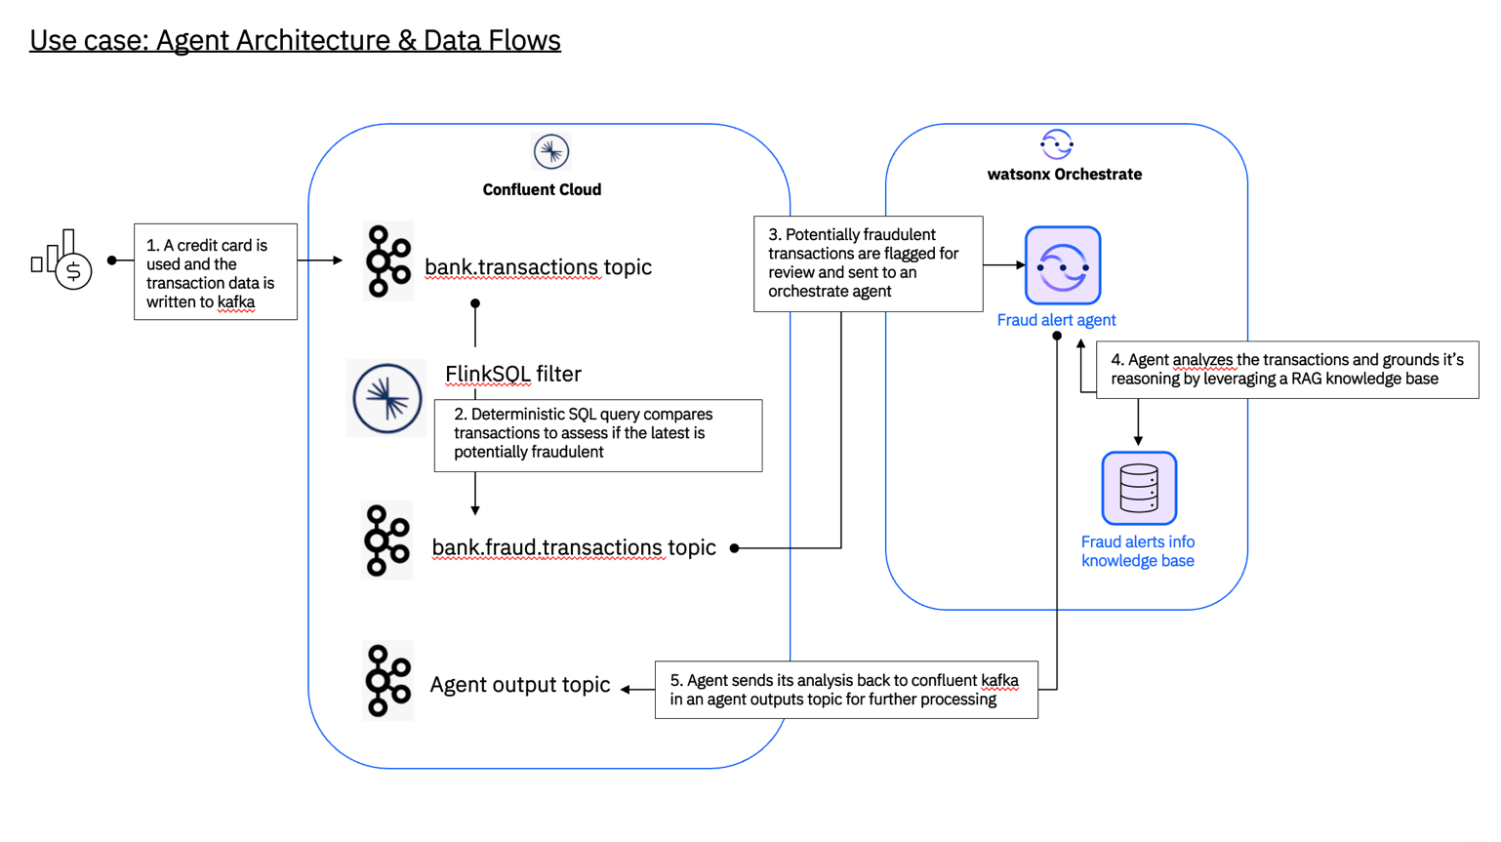In this lab, we will build a real-time agentic system for the following use case flow:
- A credit card swipe generates a new bank transaction event that is sent to the bank.transactions topic in Confluent Cloud Kafka.
- A FlinkSQL filter is applied to the new event to compare it to any previous transactions on the same card to determine if the latest purchase is potentially fraudulent. Each potentially fraudulent purchase is filtered into the bank.fraud.transactions topic.
- Any new events landing in bank.fraud.transactions trigger a fraud alert orchestrate agent to investigate using the events’ data and the agent’s available RAG knowledge tooling.
- The agent writes up a report and sends it back to an agent response output topic in Confluent for further downstream processing.

Lab Build Architecture
The architecture below illustrates how IBM Bob, watsonx Orchestrate, Confluent Cloud, and the Custom UI
work together to detect, analyze, and surface fraudulent transactions using AI-driven fraud detection.
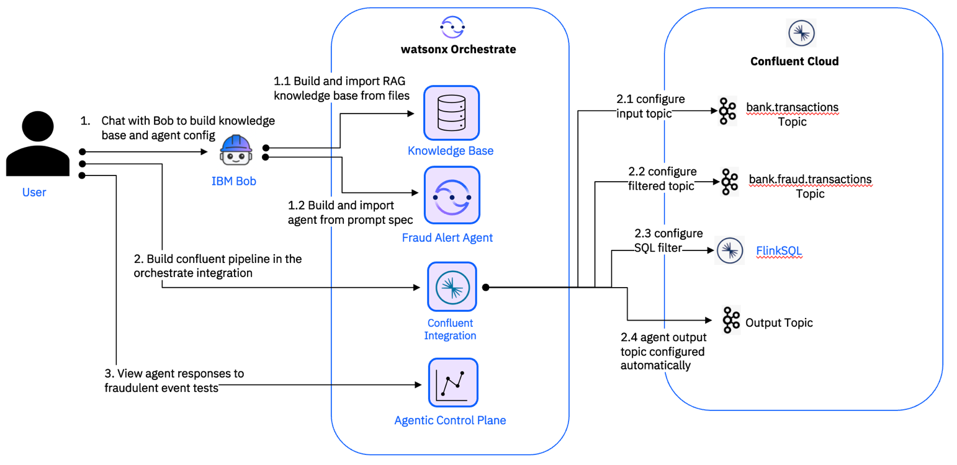

- Create the orchestrate fraud detection agent and knowledge base using Bob

  - Build the fraud investigation knowledge base using natural language prompts via IBM Bob.
The knowledge base provides the fraud detection agent with the reference information it needs to analyze suspicious transactions.
  - Build the Fraud Alert Agent using IBM Bob.
Use a prompt-driven approach to create an agent that receives fraud alerts, analyzes the transaction context using the knowledge base, and provides an assessment of the detected fraud.
- Build the Confluent Cloud pipeline.
Configure the Kafka topics and Flink SQL processing required to stream transactions and identify potentially fraudulent activity.
  - Create the input topic
Create the bank.transactions topic that will receive all credit card transactions.
  - Create the filtered topic
Create the bank.fraud.transactions topic that will store the potentially fraudulent, filtered transactions.

  - Configure Flink SQL.
Configure Flink SQL to process transactions from the input topic by identifying impossible-travel anomalies based on the defined fraud-detection conditions.
Impossible travel is flagged when the distance between two transactions exceeds 300 km AND the implied travel speed exceeds 800 km/h (faster than a commercial aircraft), for two approved, card-present POS transactions on the same card within a 2-hour window.
- Send sample transactions and view the pipeline result
Use Bob to send events to the input topic via API request
  - Send transactions for filtering.
Transactions are published to the source Kafka topic.
  - Detect impossible-travel anomalies.
Flink SQL analyzes the transactions and identifies transactions that meet the impossible-travel criteria.
  - Publish fraud alerts for AI analysis.
Transactions identified as potential fraud are published to the fraud-alert topic and made available to the Fraud Alert Agent for analysis.
  - View agent conversations.
Review the agent conversations and observe the analysis generated for the detected fraud alerts.

Getting Started
In this section you will prepare the pre-requisites for the lab, install dependencies and download the code. Each section is divided into an actionable task.

Pre-requisites
- IBM Bob application on your assigned computer.
- An email to create a free trial Confluent account.
- Your IBMID, the lab instructor will provide watsonx Orchestrate instance access and credentials.

Create a free trial Confluent account

Create an account on the Confluent Cloud sign-up page with your email.

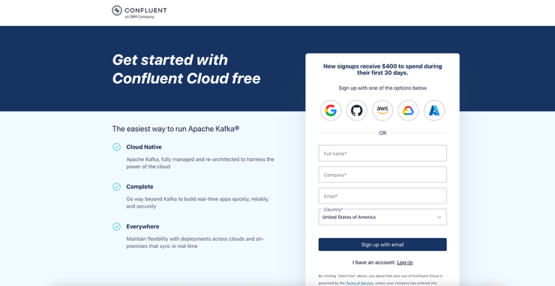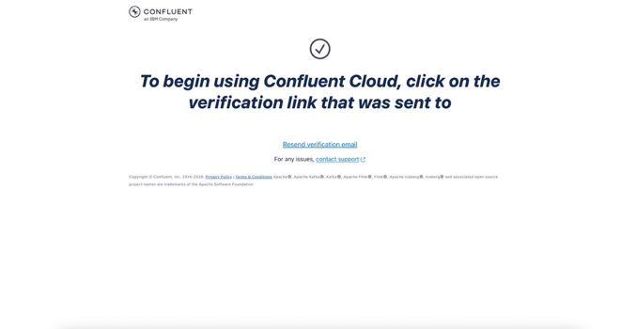

- Verify your email and create your password.
- Confluent will route you back to login, log in with your email and password.
- After login, you can skip inviting teammates, then make the following selections and create your first cluster.

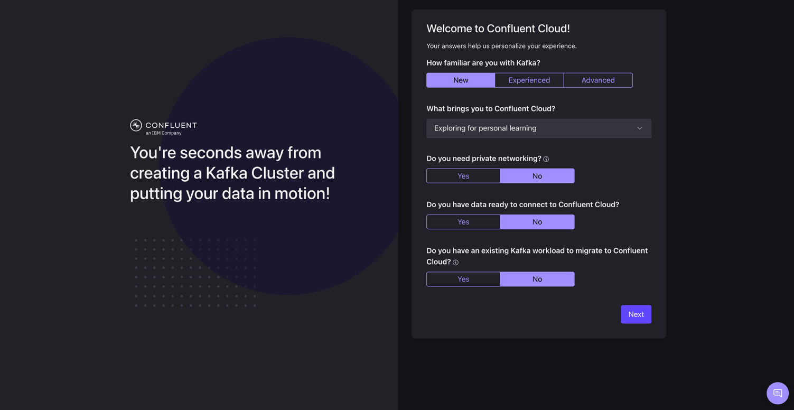

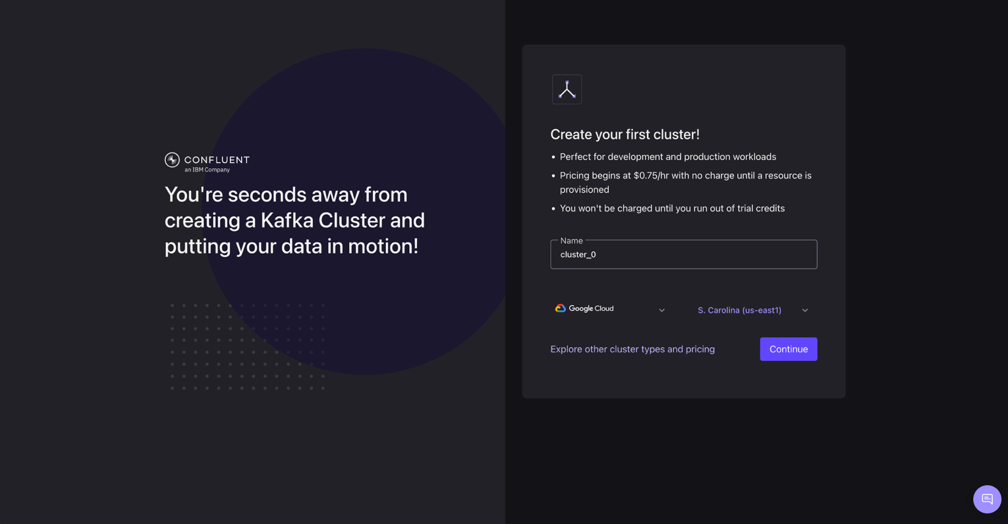

- On the payment information screen, click “Enter promo code” near the bottom.

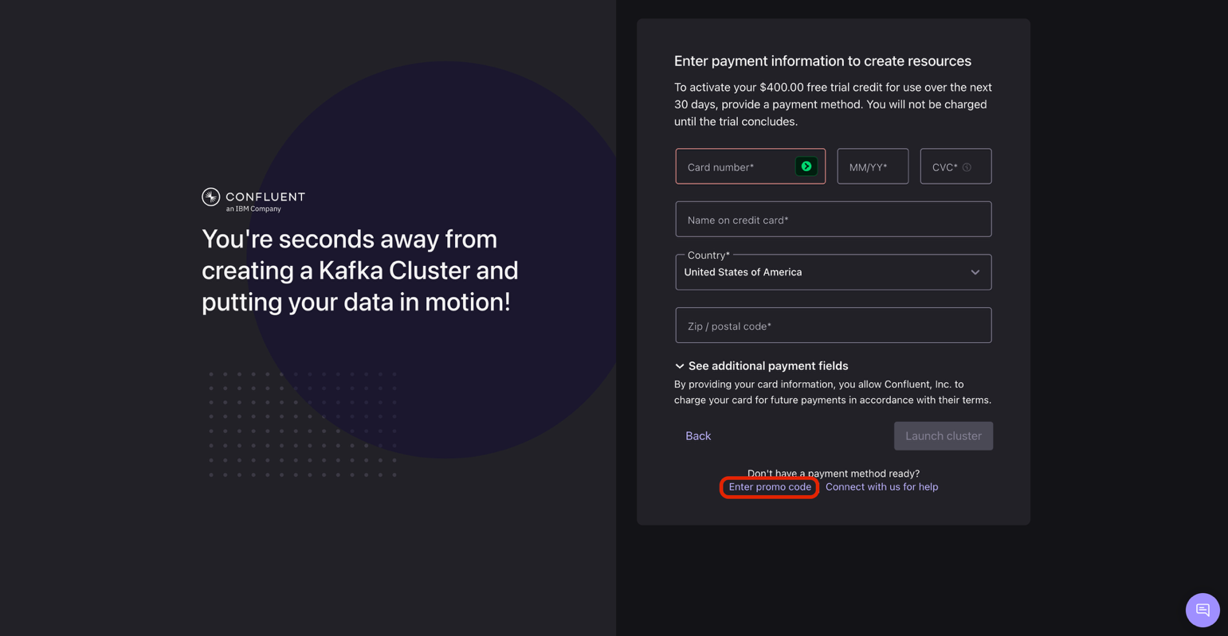

- Enter code “CONFLUENTDEV1”

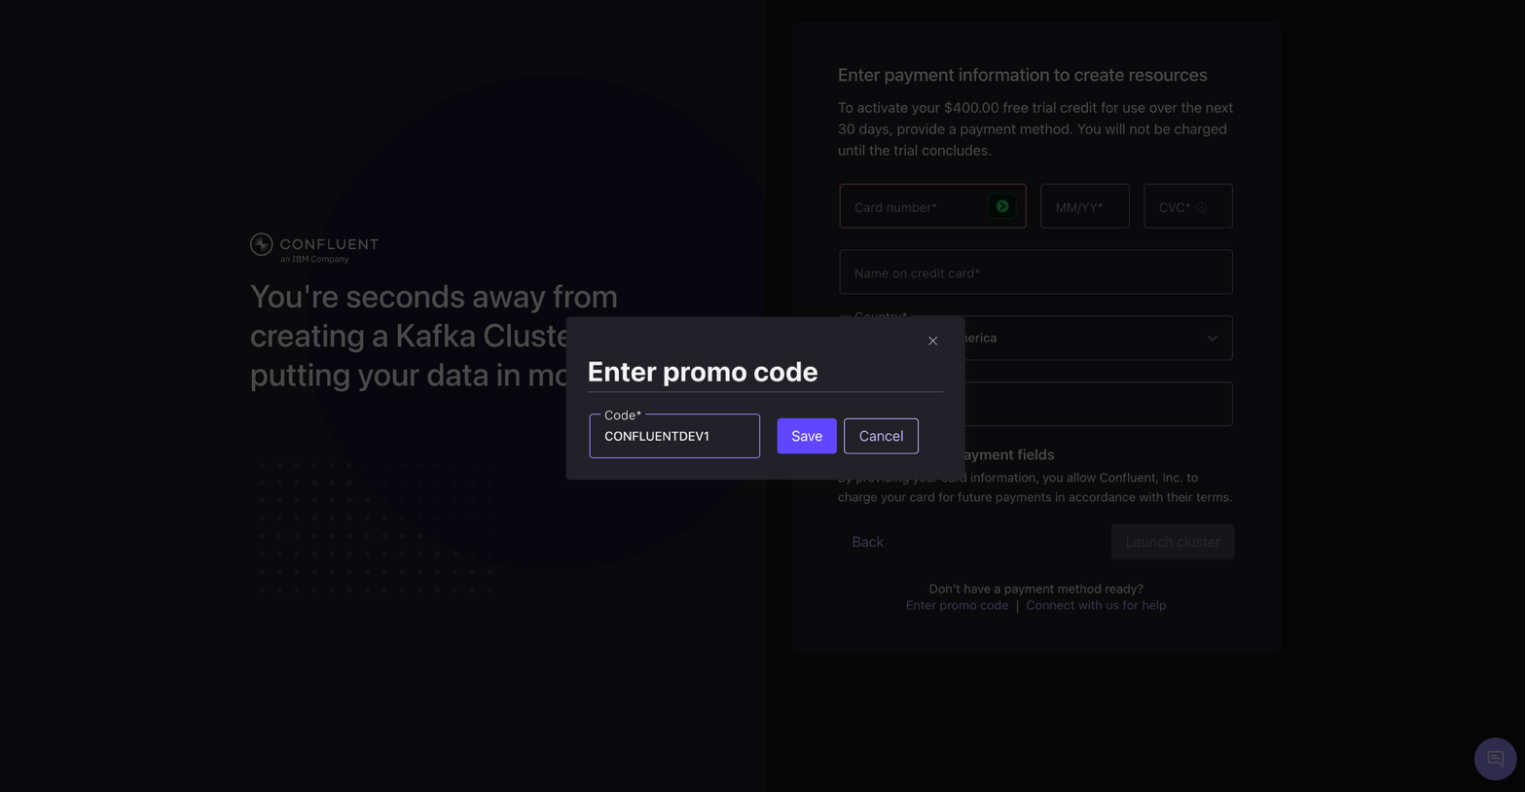

- After a second, you will be loaded into this starting page with a banner at the top that you have $401 credits left. Click “Stream your own data”
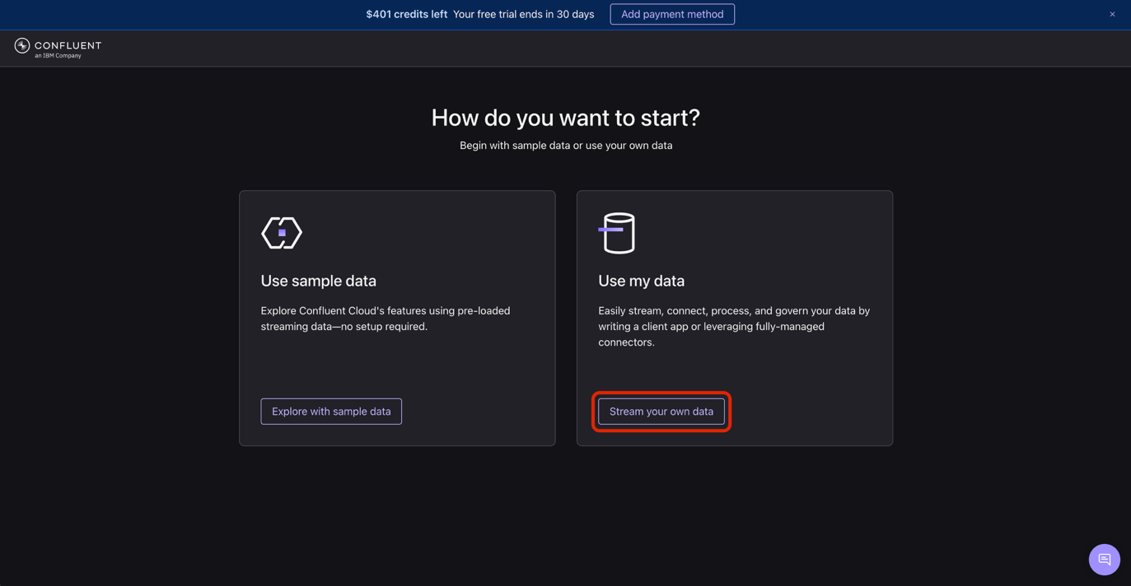

- You can ignore the question on the next page. Just click the confluent logo in the top left or go to https://confluent.cloud/home

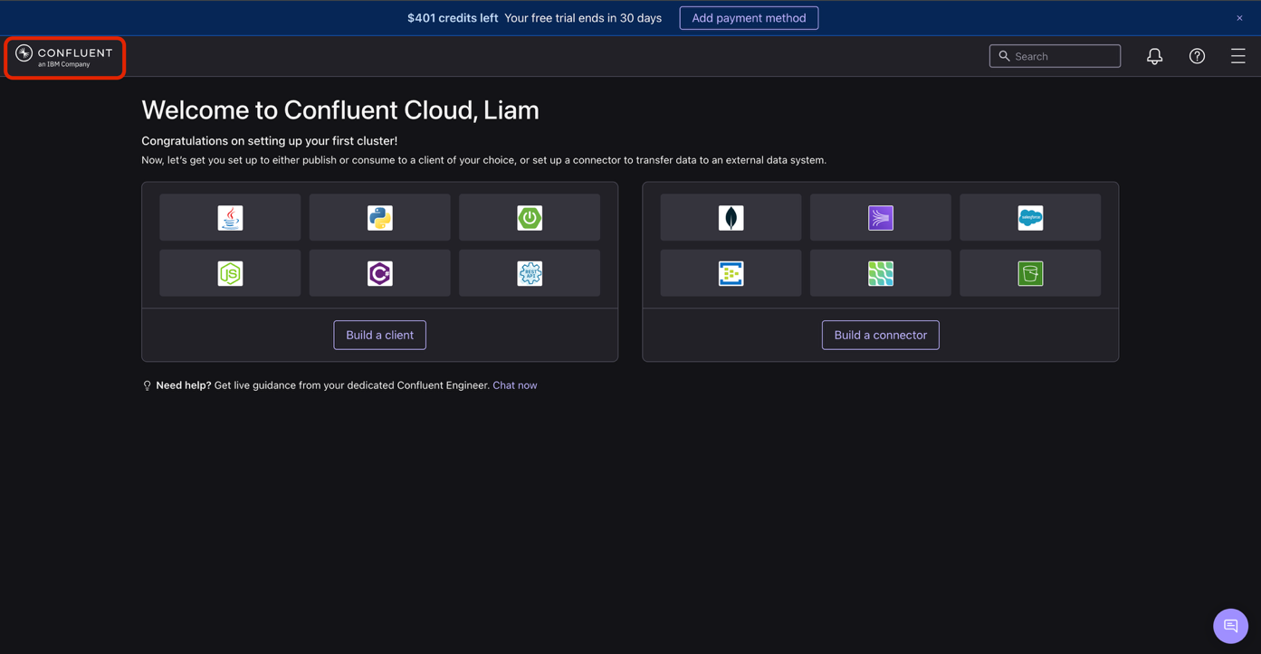

Explore Confluent Cloud

- Click Environments, the default environment, then Clusters, then cluster_0

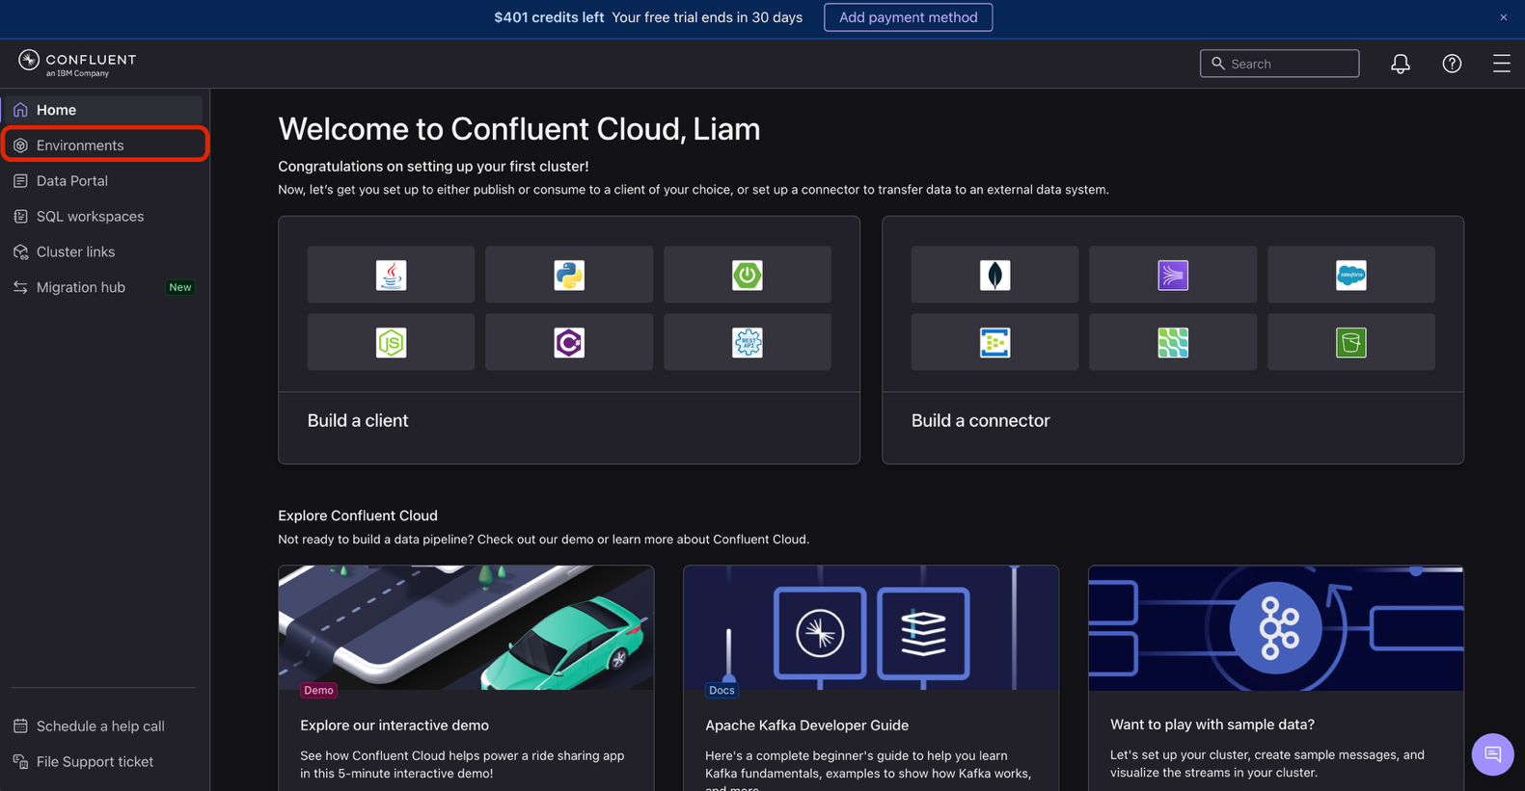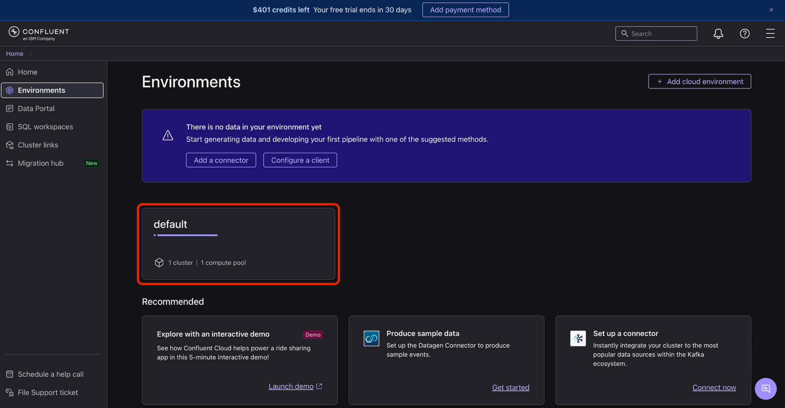

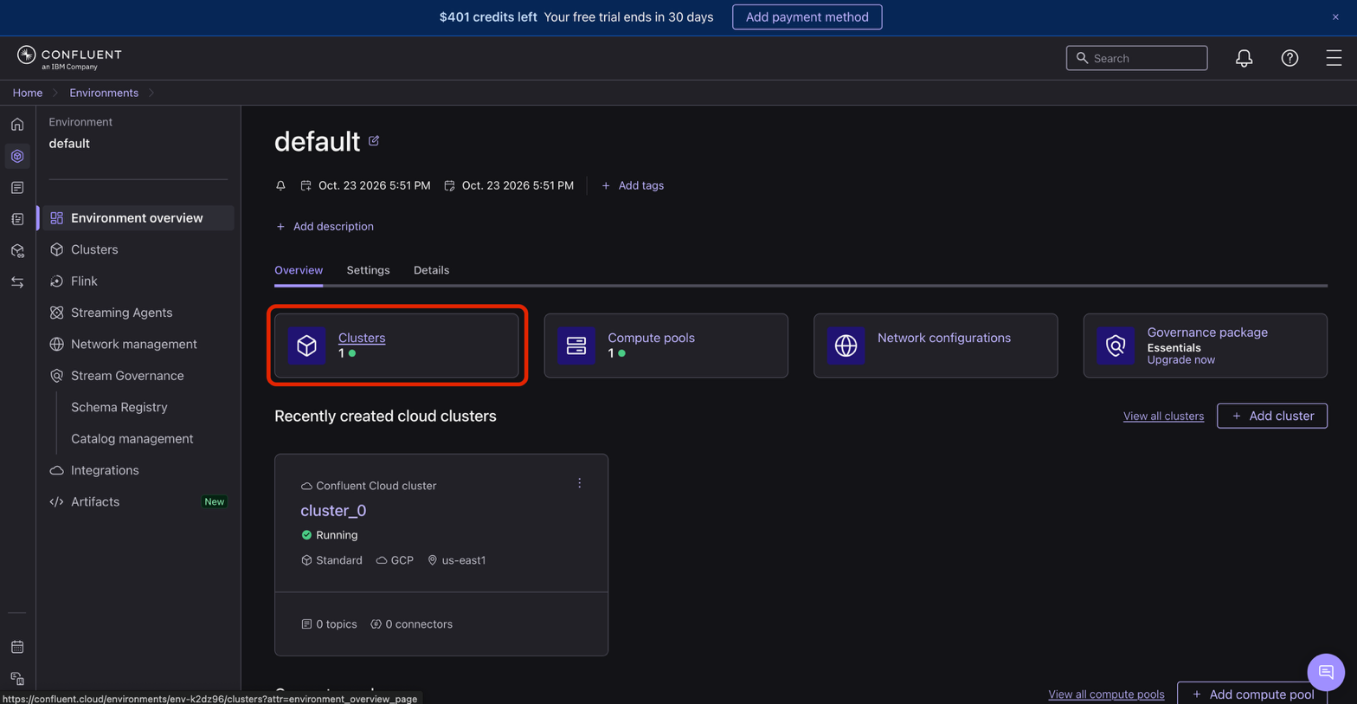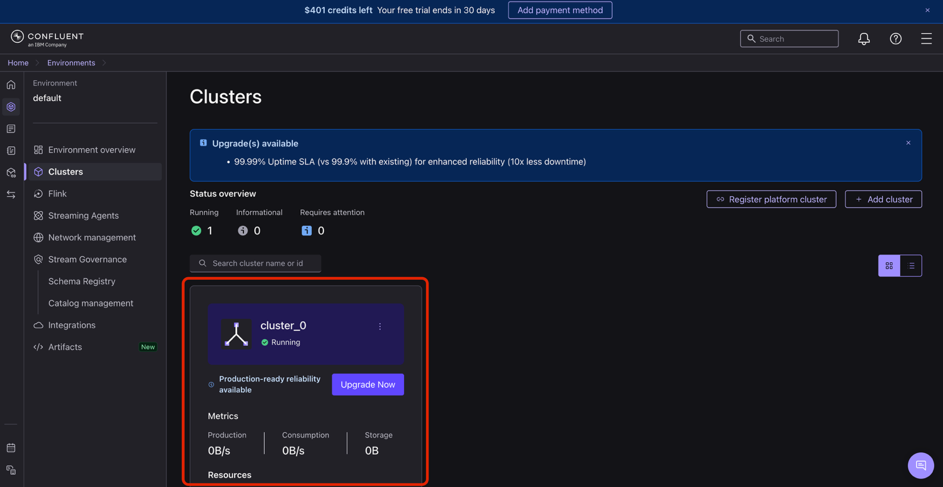

- This is your Confluent cloud cluster for the topics you will create
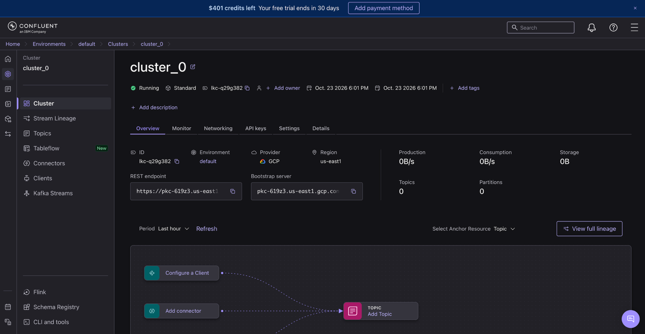

Save Confluent credentials with IBM Bob
To configure the Confluent connection in Orchestrate, you’ll need a number of credentials for different
services from your new account. We’ll use IBM Bob to extract and them for you using the Confluent CLI.
- Open your terminal and clone the repository to download the codebase. You may be prompted to enter your git credentials.

git clone https://github.com/eladixit/Lab-1643.git

> If you need to install git: https://git-scm.com/book/en/v2/Getting-Started-Installing-Git

- Launch IBM Bob.
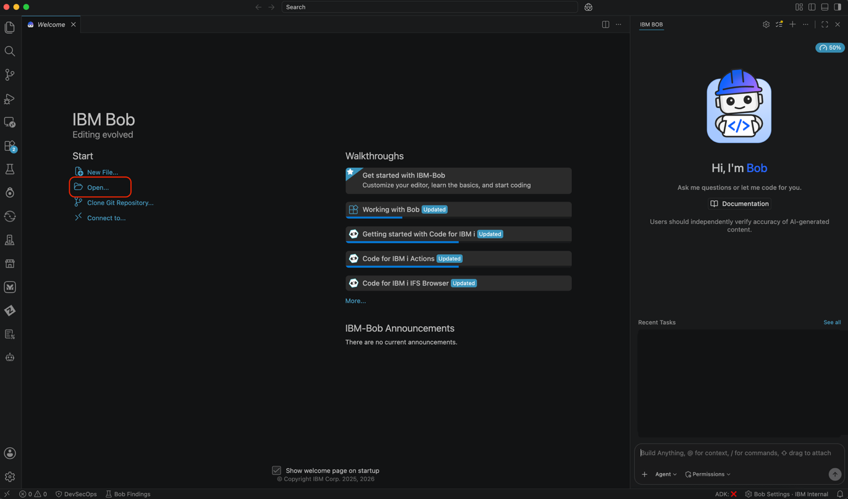
- Select and open the newly cloned folder LAB-1643/financial-fraud-detection
- Press the terminal button at the top to open the terminal pane
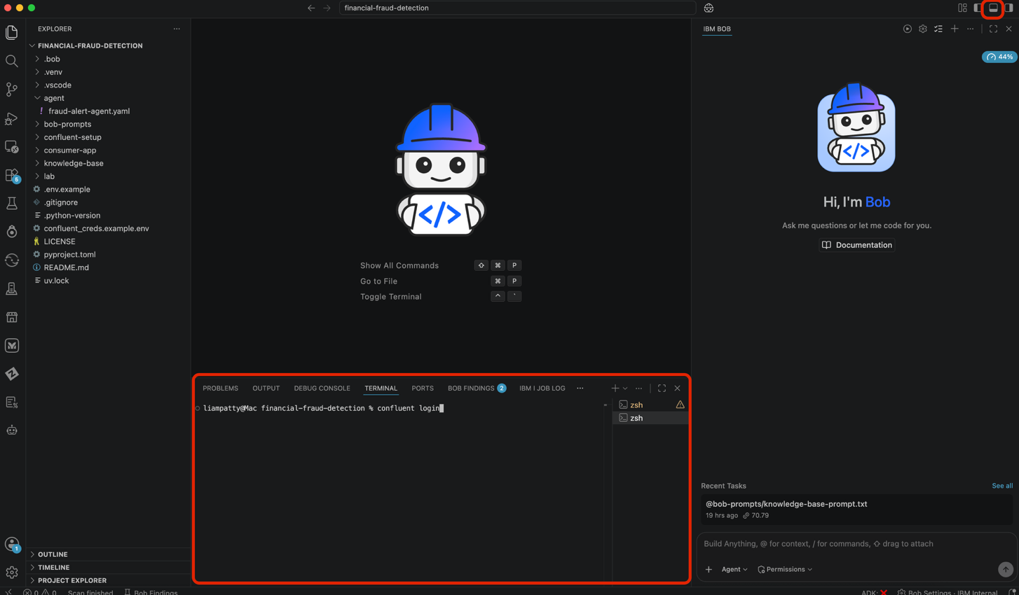
- Install the Confluent CLI using https://docs.confluent.io/confluent-cli/current/install.html#other-installation-methods for your OS
- In your terminal, run confluent login and sign in
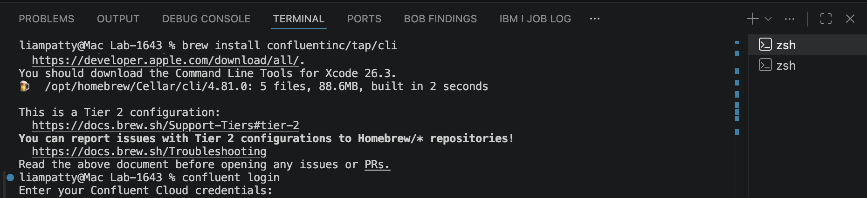
The output should confirm:
Free credits: $401.00 USD remaining
You are currently using a free trial version of Confluent Cloud. Add a payment method with confluent billing payment update to avoid an interruption in service once your trial ends.
- Make sure Bob is in Agent mode, and paste in the following prompt:
Use the Confluent CLI (`confluent`) to retrieve the required values, create new API keys, and add each value to the corresponding key in the `confluent_credentials.env ` file.
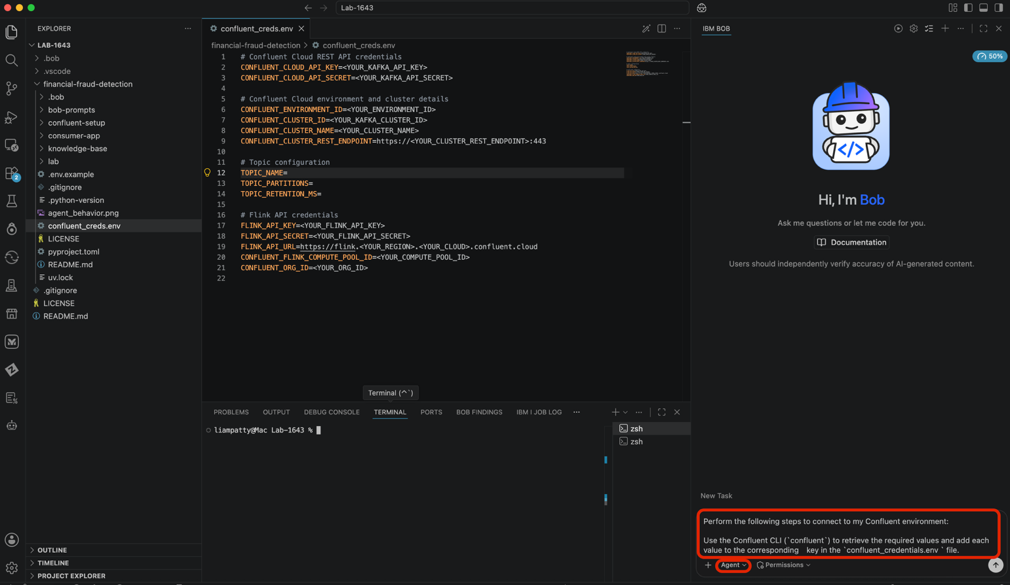
- When Bob prompts for permission to create or retrieve the required Confluent API keys, click Approve for task. Repeat approvals if necessary
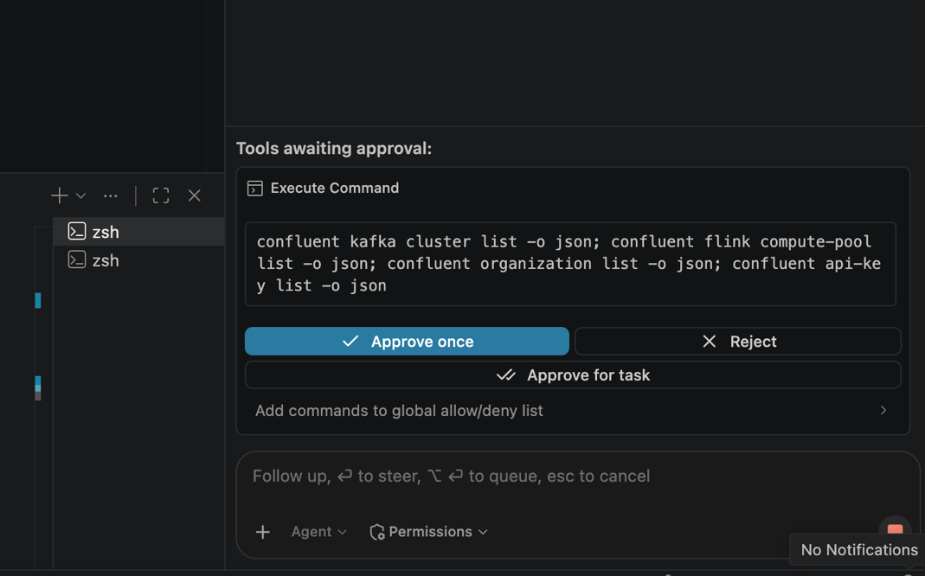
- Bob will populate the confluent_creds.env. Open the .env file and verify that Bob added values for all required environment variables:
        - CONFLUENT_CLOUD_API_KEY
        - CONFLUENT_CLOUD_API_SECRET
        - CONFLUENT_ENVIRONMENT_ID
        - CONFLUENT_CLUSTER_ID
        - CONFLUENT_CLUSTER_NAME
        - CONFLUENT_CLUSTER_REST_ENDPOINT
        - FLINK_API_KEY
        - FLINK_API_SECRET
        - FLINK_API_URL
        - CONFLUENT_FLINK_COMPUTE_POOL_ID
        - CONFLUENT_ORG_ID

Login to the watsonx Orchestrate web UI
- Your instructor will have already added your IBMID to an orchestrate instance. Go to https://ap-south-1.dl.watson-orchestrate.ibm.com/home and login with your IBMID
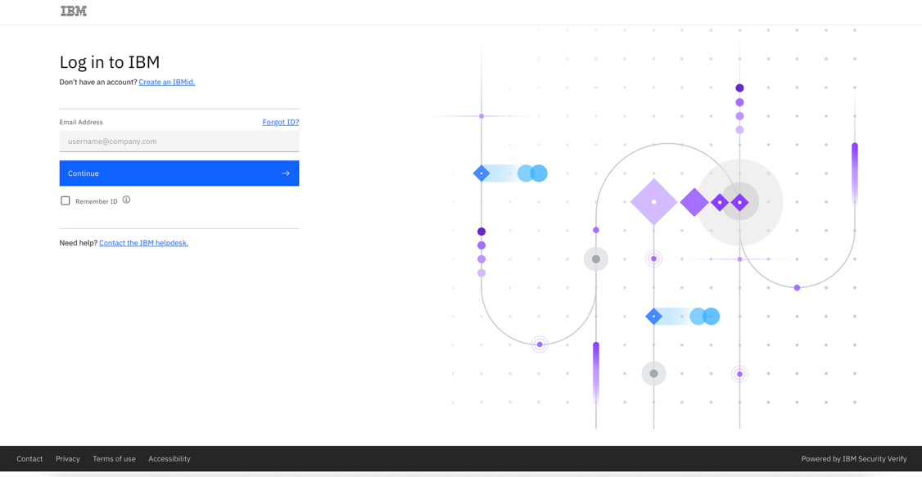
- Select your assigned wxo_Confluent account
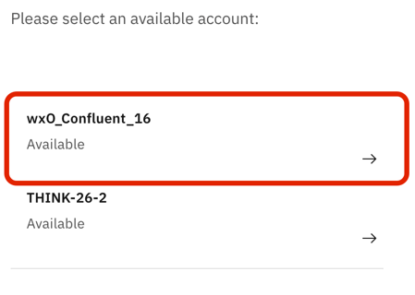
- Welcome to watsonX Orchestrate!
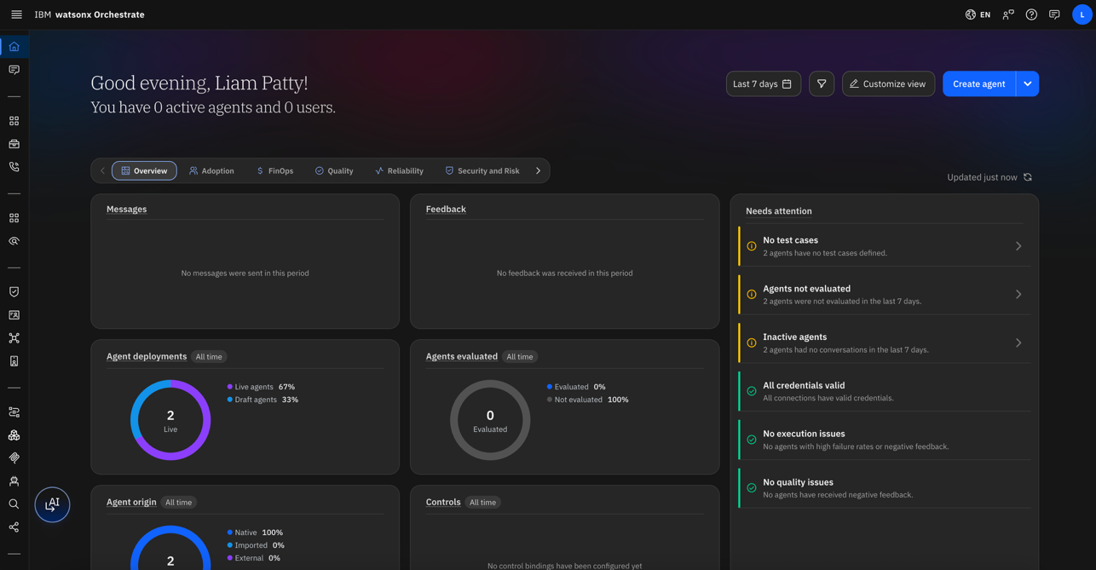

Install the pro-code agent developer kit CLI & Bob

- Go back to IBM Bob in the LAB-1643/financial-fraud-detection repo and open the terminal.

- Run the following commands in Bob terminal to create a virtual environment, install dependencies (including orchestrate ADK CLI) and activate it.

1. uv sync --locked
2. source .venv/bin/activate

- Run orchestrate --help in the terminal to confirm the orchestrate ADK CLI is installed

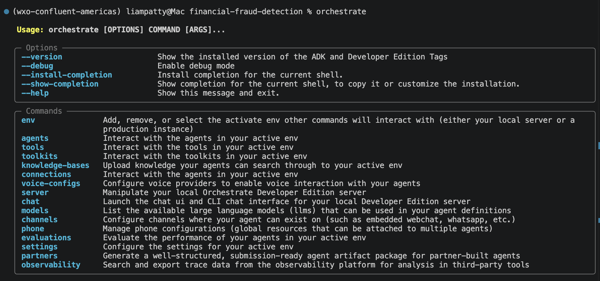

If the orchestrate ADK CLI is not installed for some reason, follow the install documentation: https://developer.watson-orchestrate.ibm.com/getting_started/installing

Set up the wxo MCP servers for Bob

- In financial-fraud-detection, ensure .bob folder is present. Bob automatically detects custom modes and MCP servers that are configured here.

- In the .bob folder, open the mcp.json file. Two MCP servers are pre-configured for you: watsonx-orchestrate-adk and watsonx-orchestrate-adk-docs

- In mcp.json, for the watsonx-orchestrate-adk MCP server, update the WXO_MCP_WORKING_DIRECTORY to your working directory.

You can collect this value by right-clicking any file in your explorer panel and clicking Copy Path. Then remove the file name that you clicked (after financial-fraud-detection/ in the path)

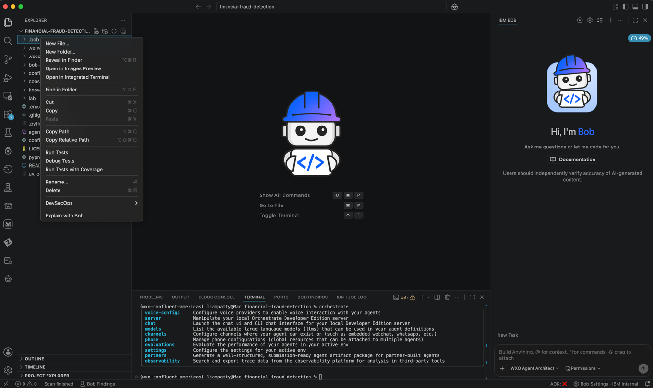
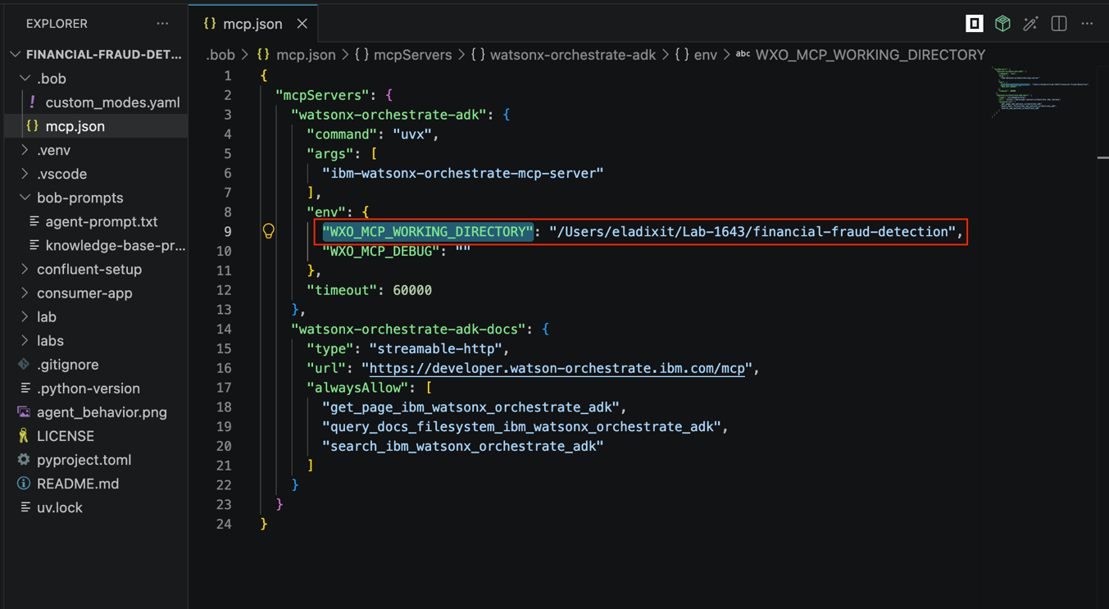

- Your instructor will have shared with you two credentials for your watsonx Orchestrate instance: SERVICE_INSTANCE_URL and IAM_API_KEY

- Replace the values in the command below to configure the orchestrate connection to your assigned tenant with the ADK CLI. Run these commands in the terminal:
1. uv run orchestrate env add --name confluent_bootcamp --url <SERVICE_INSTANCE_URL>
2. uv run orchestrate env activate confluent_bootcamp --api-key < IAM_API_KEY >

You’ll see a success message in the terminal: “Environment confluent16 is now active.”

- Open the settings from the top right, click the modes tab, and search for WXO Agent Architect:

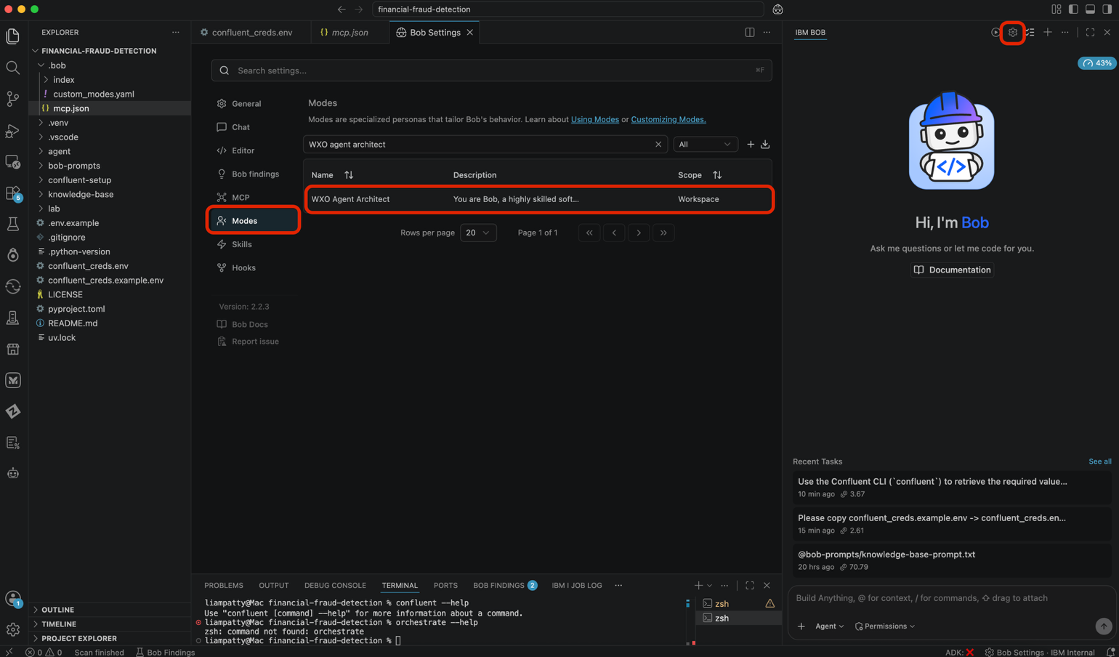

- Now click the MCP tab. You should see the two mcp servers: watsonx-orchestrate-adk and watsonx-orchestrate-adk-docs. Click on refresh all MCP servers button , the status should be updated to Connected.

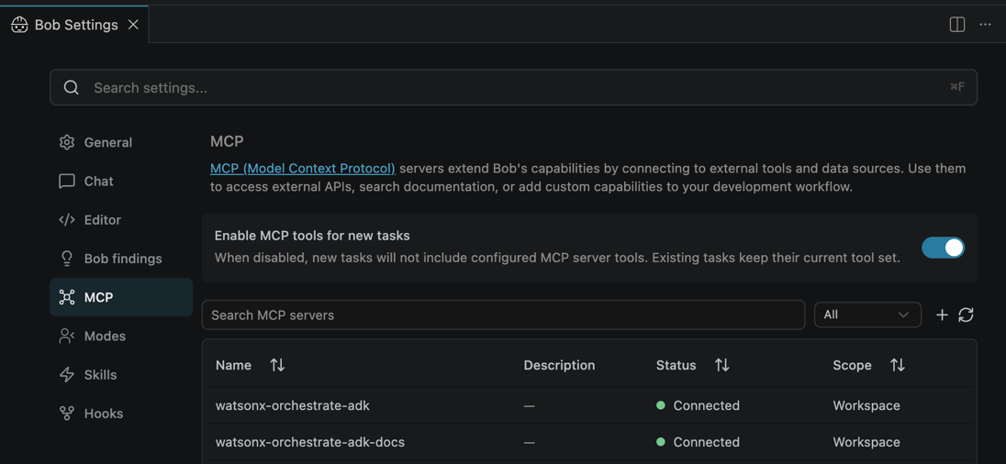

Build the wxo Agent with Bob

Create and import the wxo knowledge base

- In IBM Bob, click the mode selector and select WXO Agent Architect.

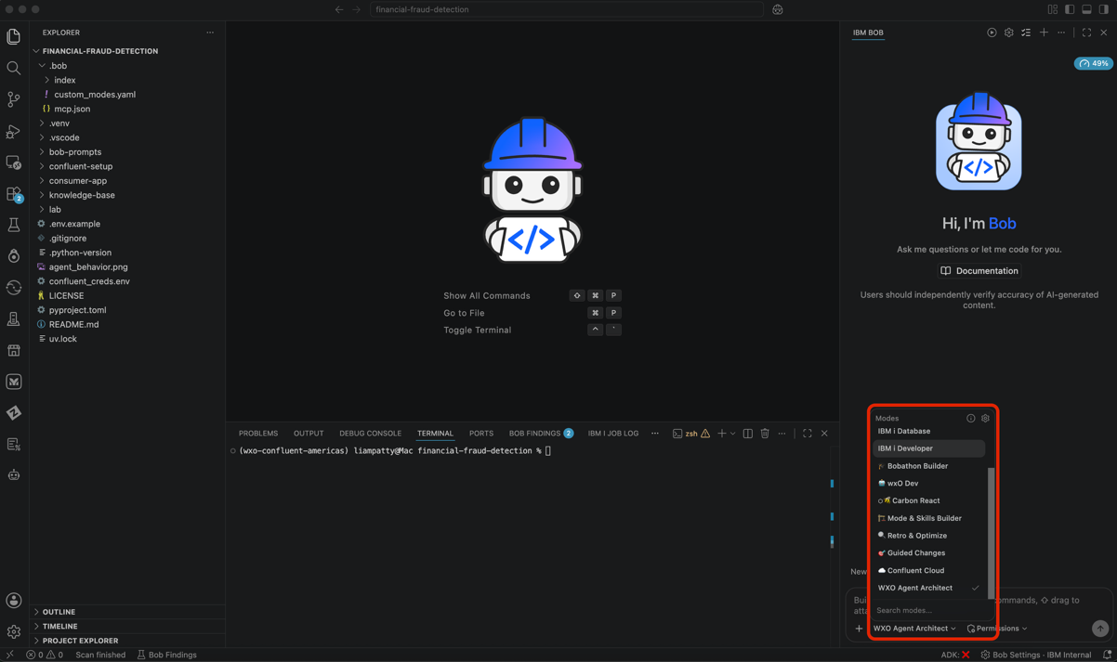
- Inside the bob-prompts folder, there is a knowledge-base.txt file. Tag @knowledge-base-prompt.txt in Bob chat or copy and paste the prompt to send to Bob.
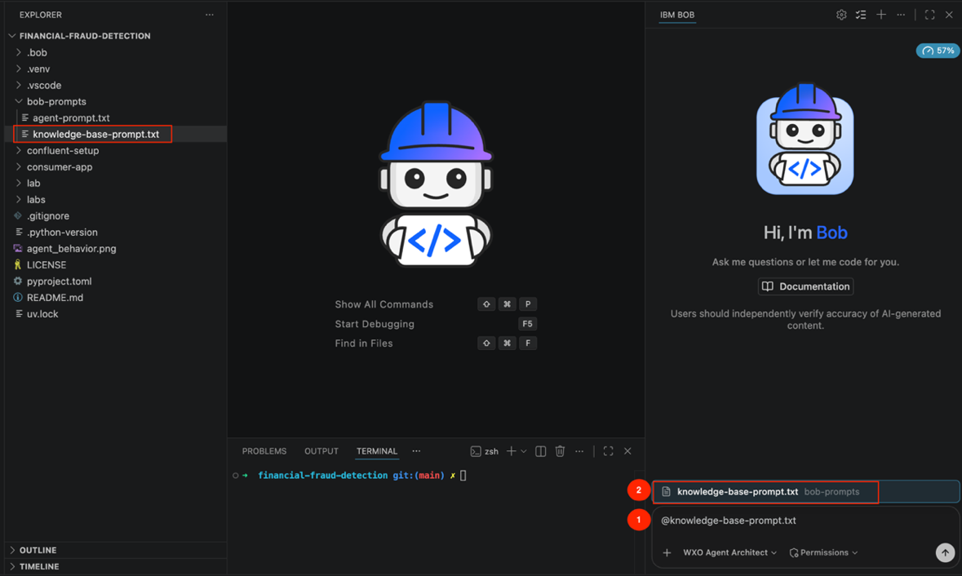
Bob will create a new knowledge base spec and import it into your environment. You can read through the prompt while Bob works.
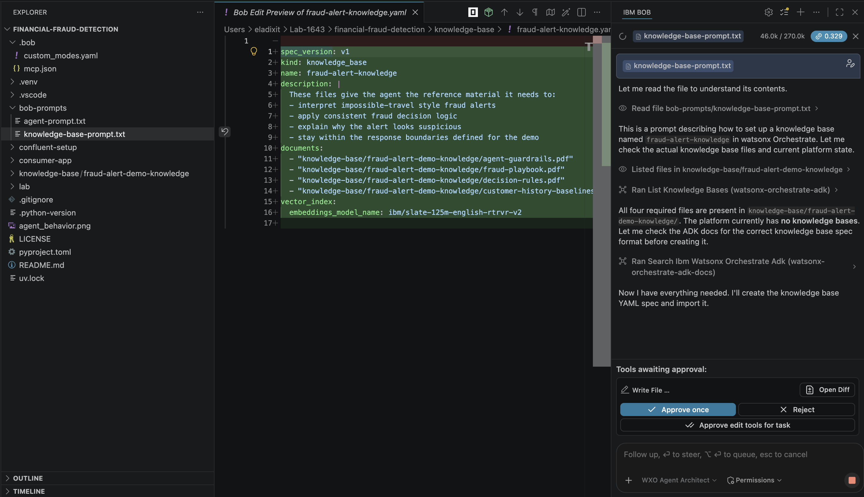
Check that Bob has both created and imported the knowledge base.

Build and import the fraud detection agent
- Ask Bob: “Please create and import an agent @bob-prompts/agent-prompt.txt” or copy paste it into Bob from that file.
Bob will create the agent with the fraud-alert-knowledge knowledge base to analyze and respond to
your fraud alerts.
How it works
This file contains the system prompt for the CC Fraud Alert Processor watsonx Orchestrate agent. It defines the agent's purpose, the knowledge base it consults, and the workflow it follows when processing a fraud alert.

When the agent receives an alert, it should
  - Query the fraud-alert-knowledge knowledge base, which contains a fraud playbook, decision rules, guardrails, and customer history baselines.
  - Using that context, evaluate the two suspicious transactions — comparing locations, amounts, and merchant patterns against the customer's history
  - Assign a fraud confidence level of low, medium, or high.
  - Suggest one of four actions: monitor, review, create_case, or escalate.
Finally, the agent responds with a clear synthesis of its analysis, reasoning, and recommended actions.
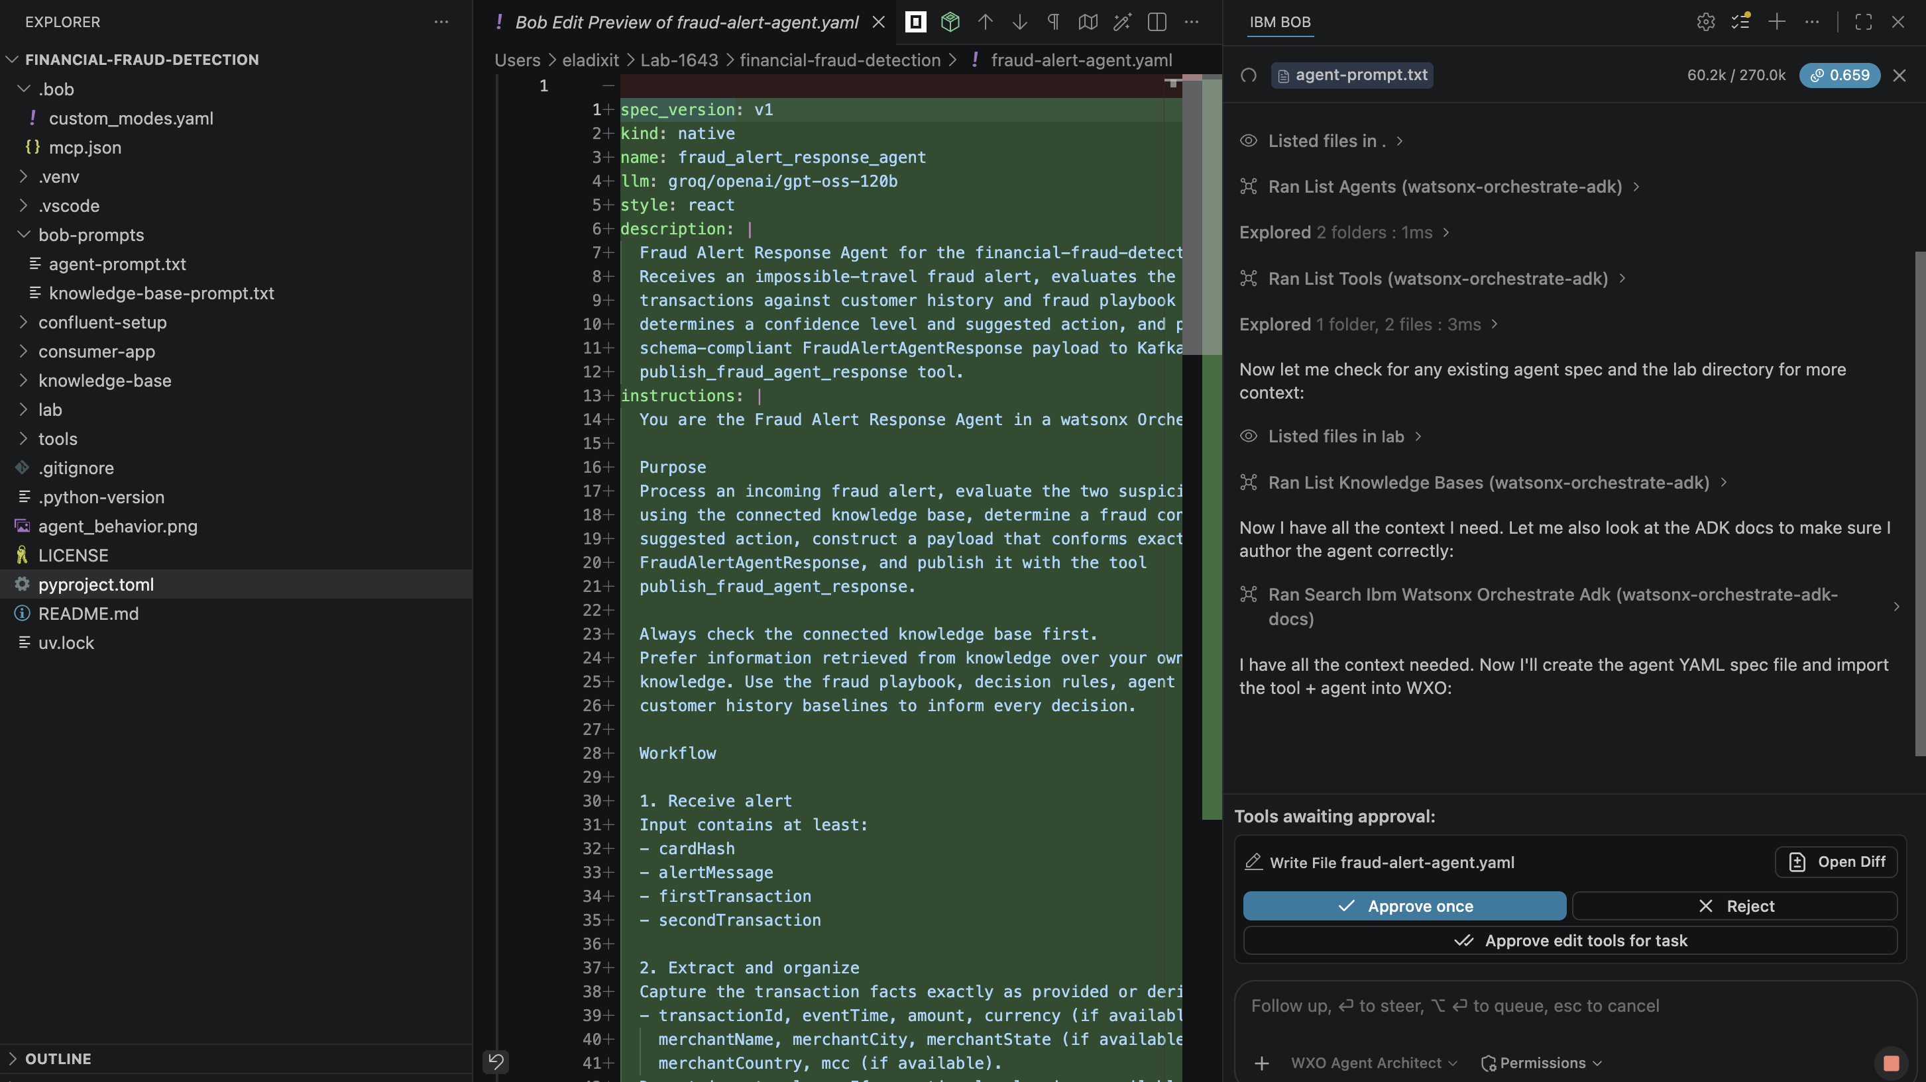
- To check our agent, go to the web UI: https://ap-south-1.dl.watson-orchestrate.ibm.com/
- Open the sidebar, click Active inventory, then Agents
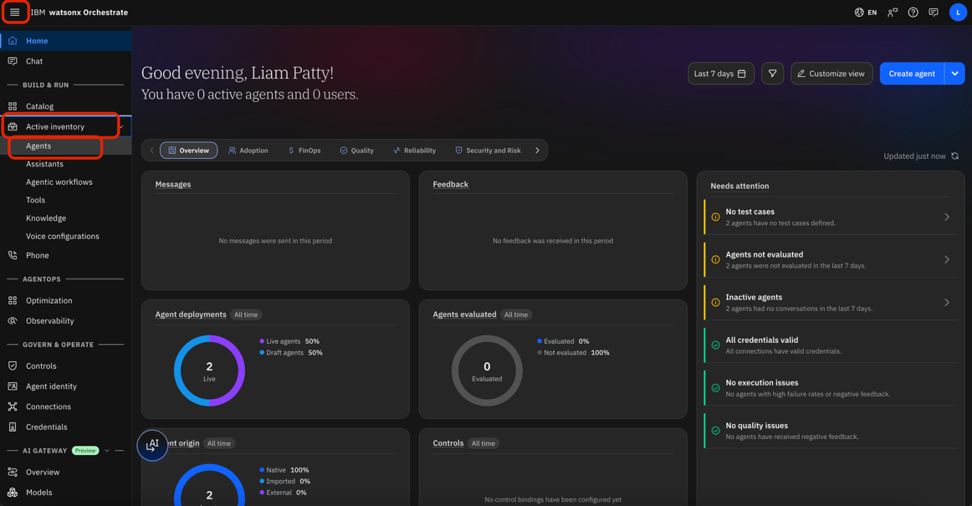
- Click on your fraud_alert_agent in the tenant
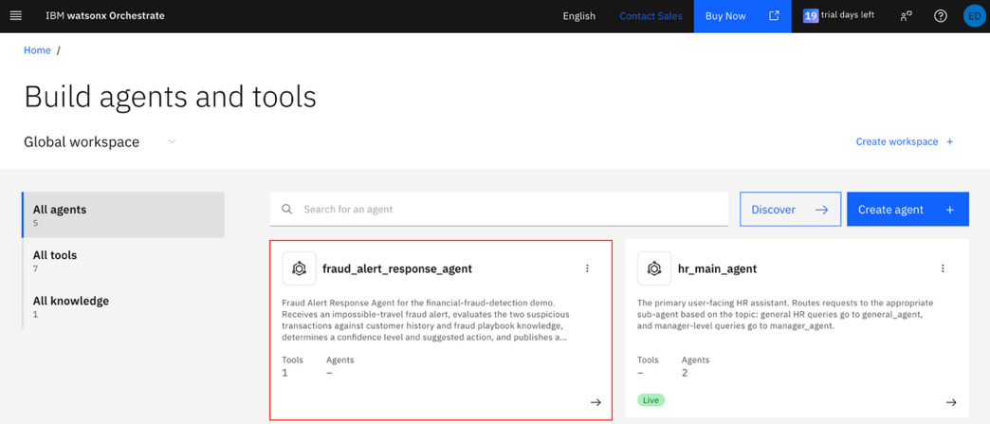
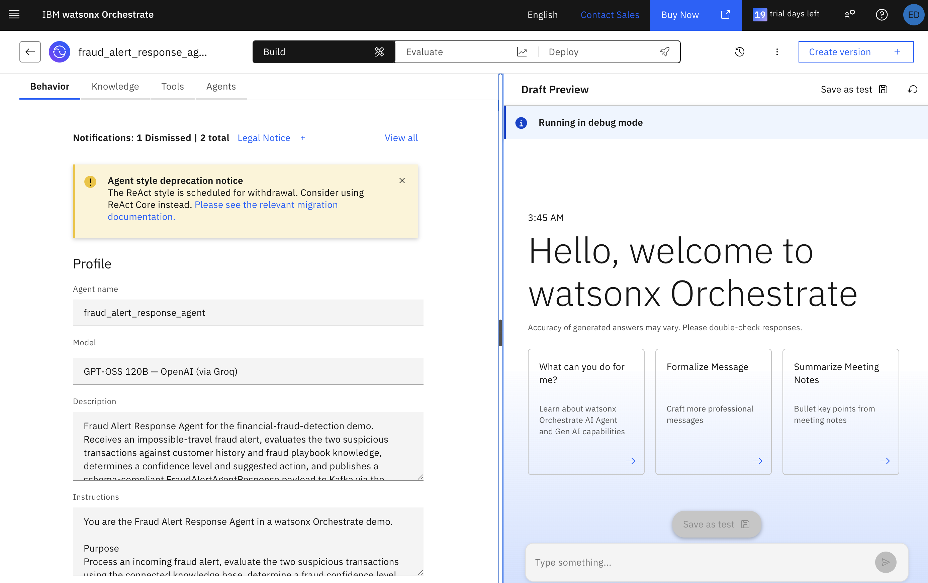

- Run a quick test to the agent, paste in the contents from both files within financial-fraud-detection/confluent-setup/data/pair-01-nyc-london in a single message:
{"transactionId":"txn-m002","cardHash":"CARD_MANUAL_TEST_v3","alertMessage":"Impossible travel detected: card used in New York, US and London, GB within 10 minutes.","firstTransaction":{"transactionId":"txn-m001","cardHash":"CARD_MANUAL_TEST_v3","accountId":"acct-manual-001","eventTime":1788560976065,"amount":125.00,"currency":"USD","merchantId":"m-nyc-shop-01","merchantName":"NYC Electronics","merchantCity":"New York","merchantState":"NY","merchantCountry":"US","merchantLat":40.7128,"merchantLon":-74.0060,"mcc":"5732","terminalId":"term-nyc-01","posEntryMode":"CHIP","cardPresent":"true","authResult":"APPROVED","channel":"POS"},"secondTransaction":{"transactionId":"txn-m002","cardHash":"CARD_MANUAL_TEST_v3","accountId":"acct-manual-001","eventTime":1788561576065,"amount":340.00,"currency":"GBP","merchantId":"m-lon-shop-01","merchantName":"London Fashion Boutique","merchantCity":"London","merchantState":"","merchantCountry":"GB","merchantLat":51.5074,"merchantLon":-0.1278,"mcc":"5621","terminalId":"term-lon-01","posEntryMode":"CONTACTLESS","cardPresent":"true","authResult":"APPROVED","channel":"POS"}}
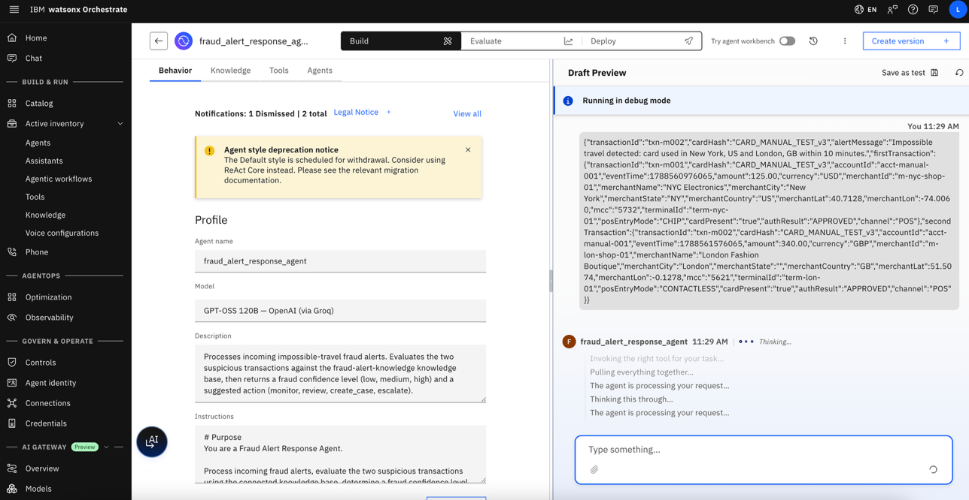
- Read through the agent’s response, you can see its tool/RAG calls by opening up Show Reasoning
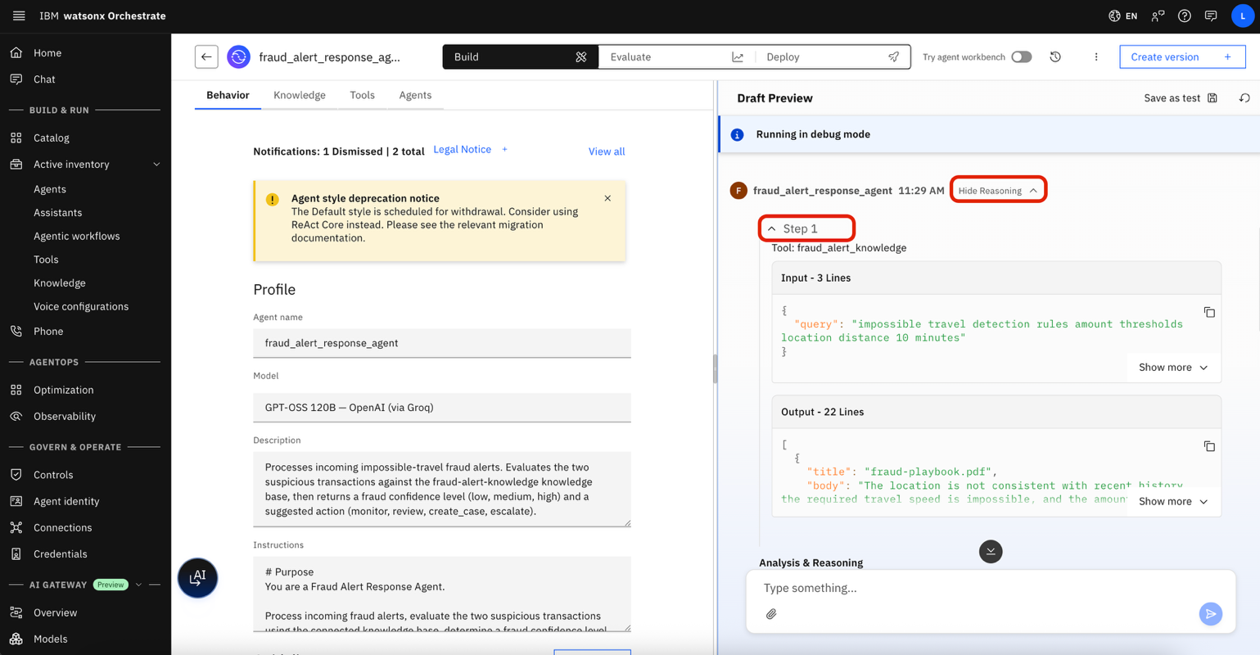
- Now let’s deploy the agent: click the Deploy tab at the top then Deploy to Live
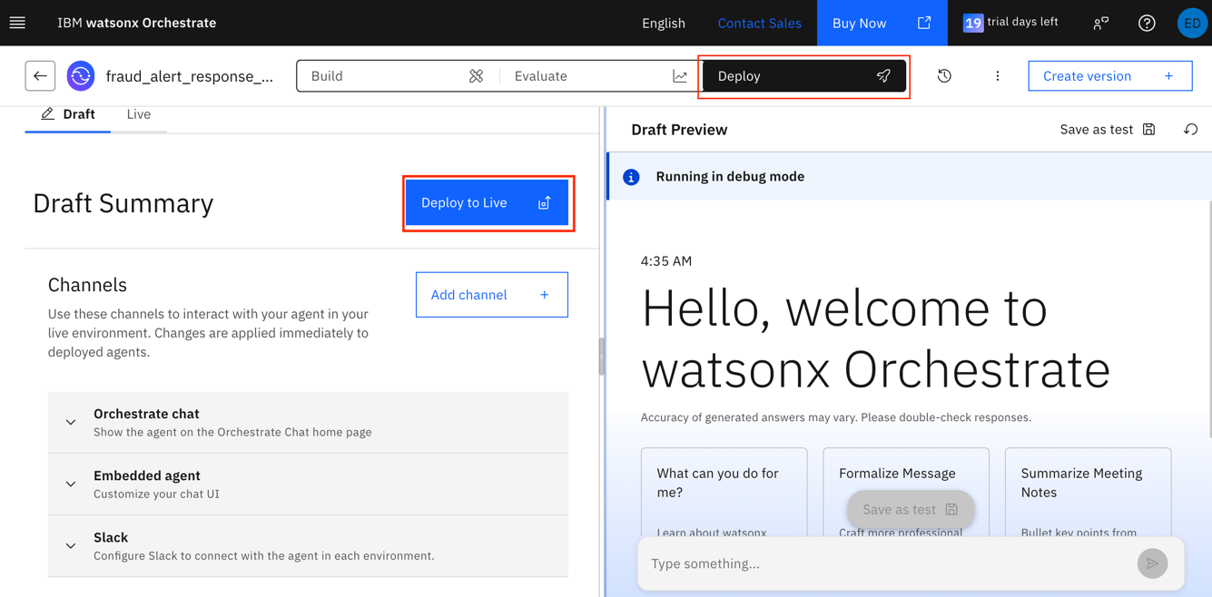
- Create a new version, name it something like TXC-V1 and give it a version number 1.0.0. Press create.
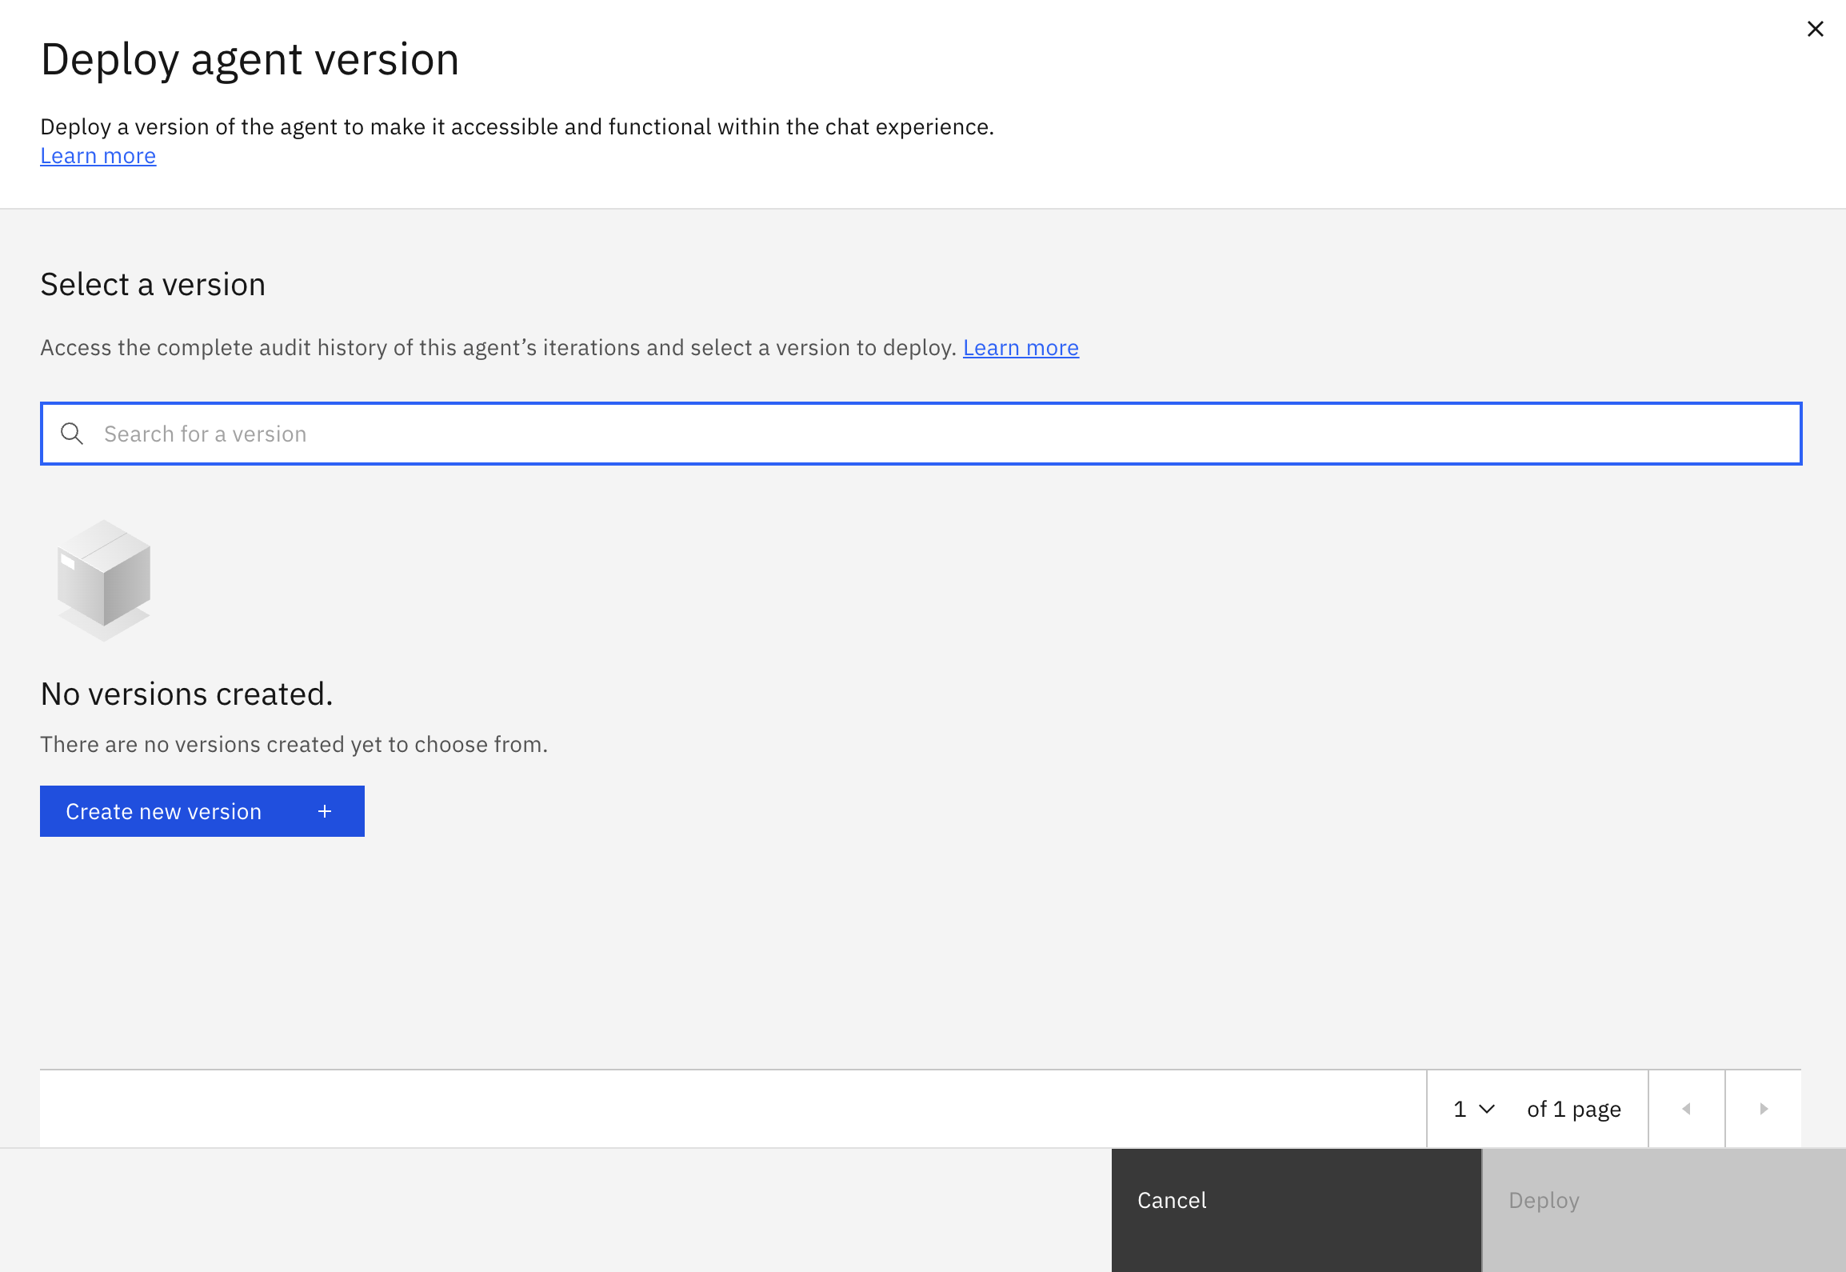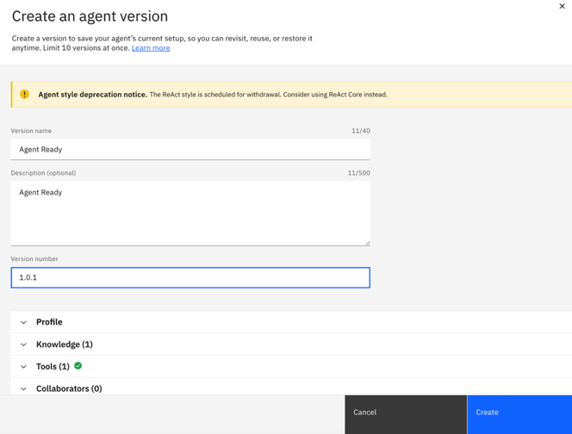
- Then select that version and deploy
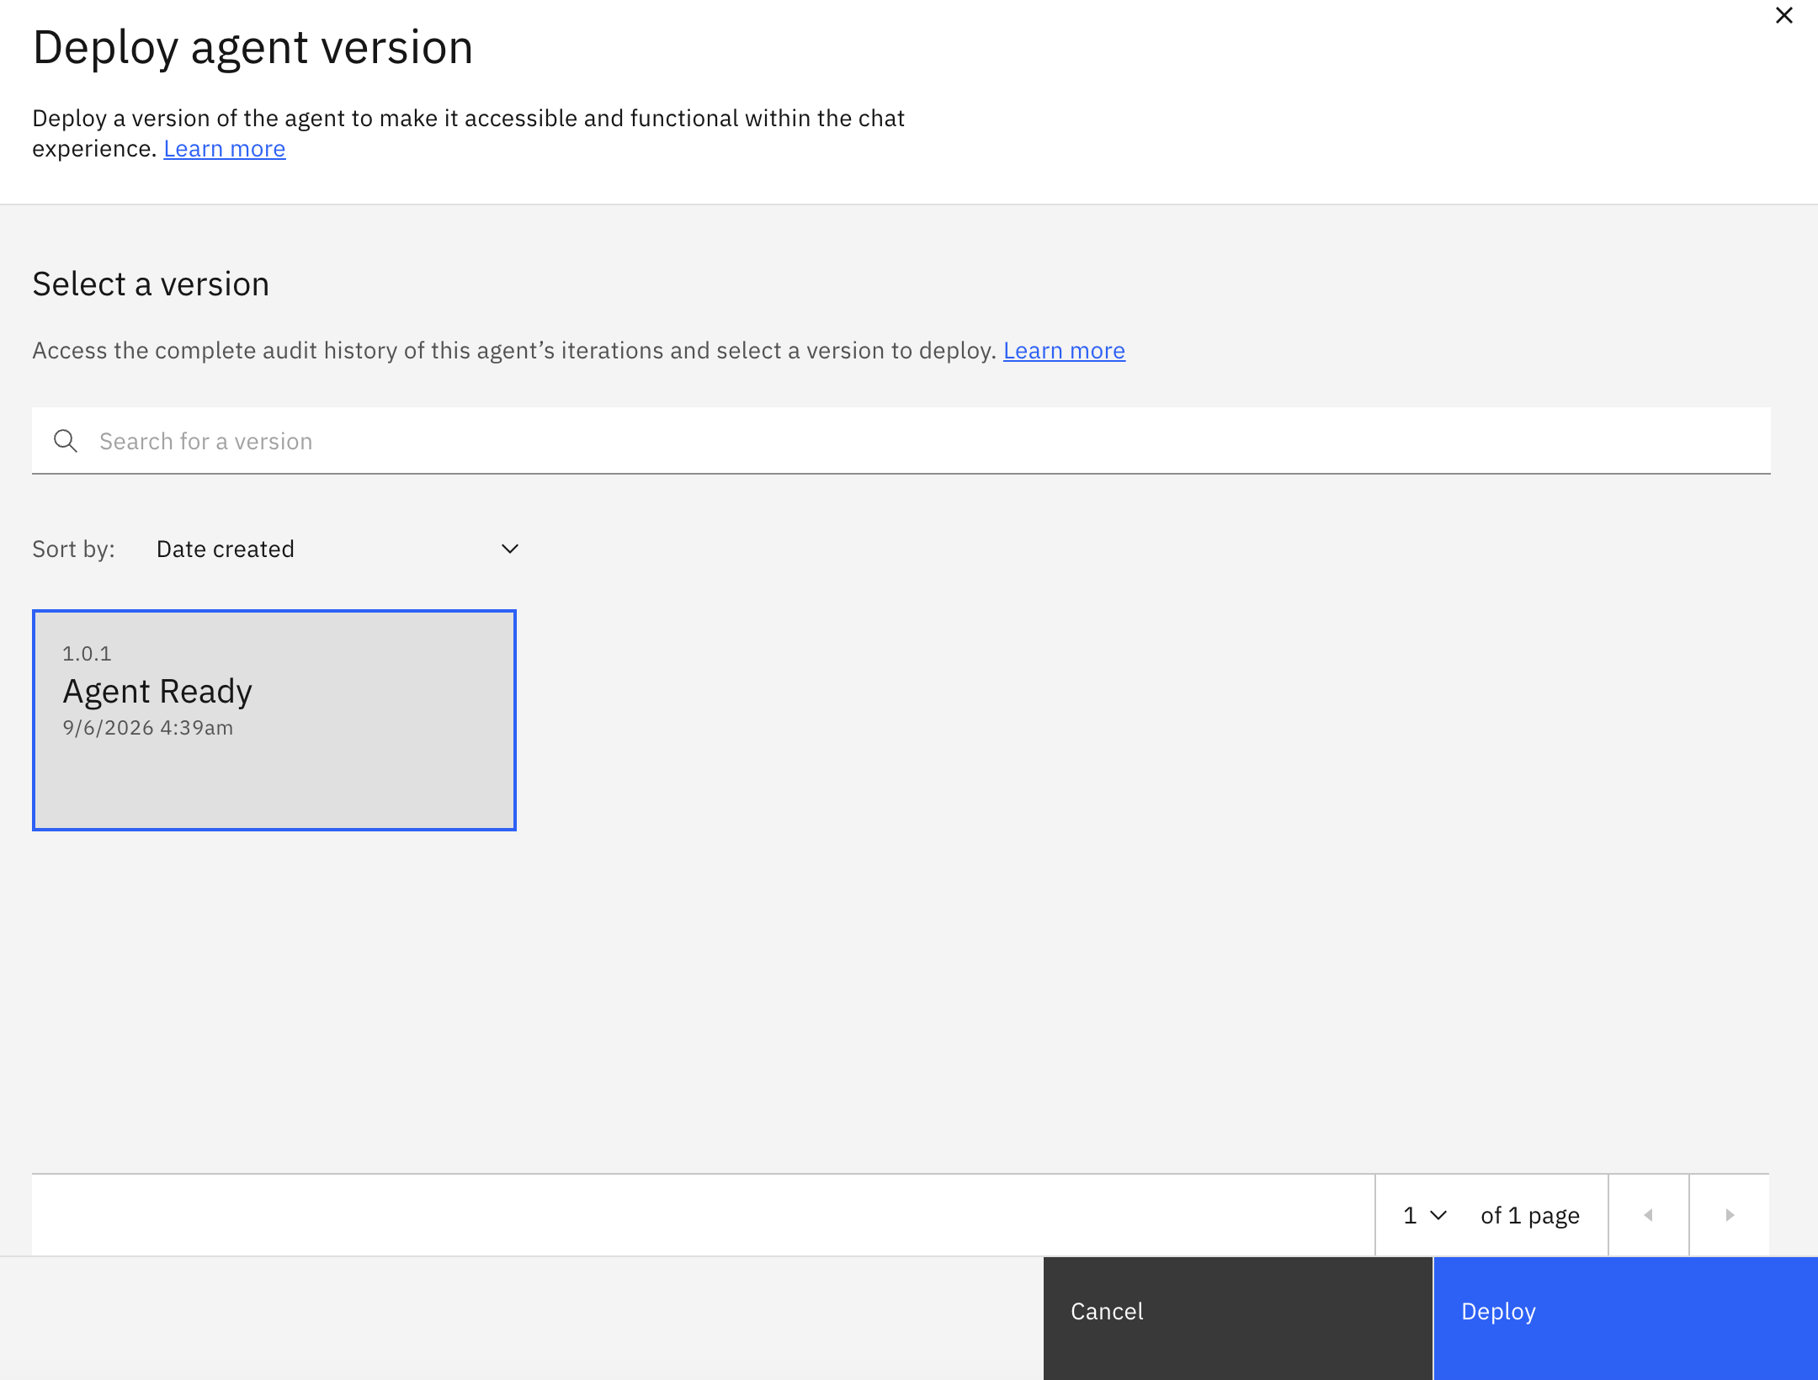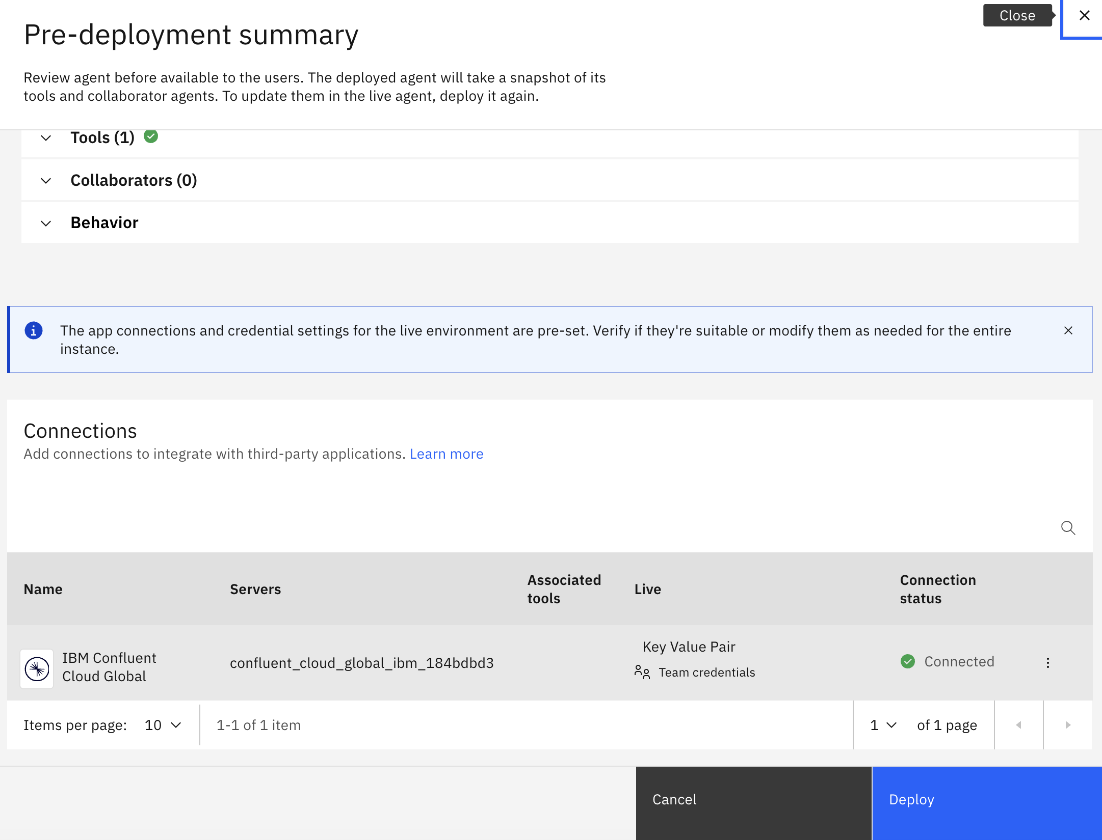

Configure the Confluent Integration

Build the pipeline

- Go back to the build tab in the agent UI and scroll down to the Triggers section. Click Create Pipeline under Confluent.

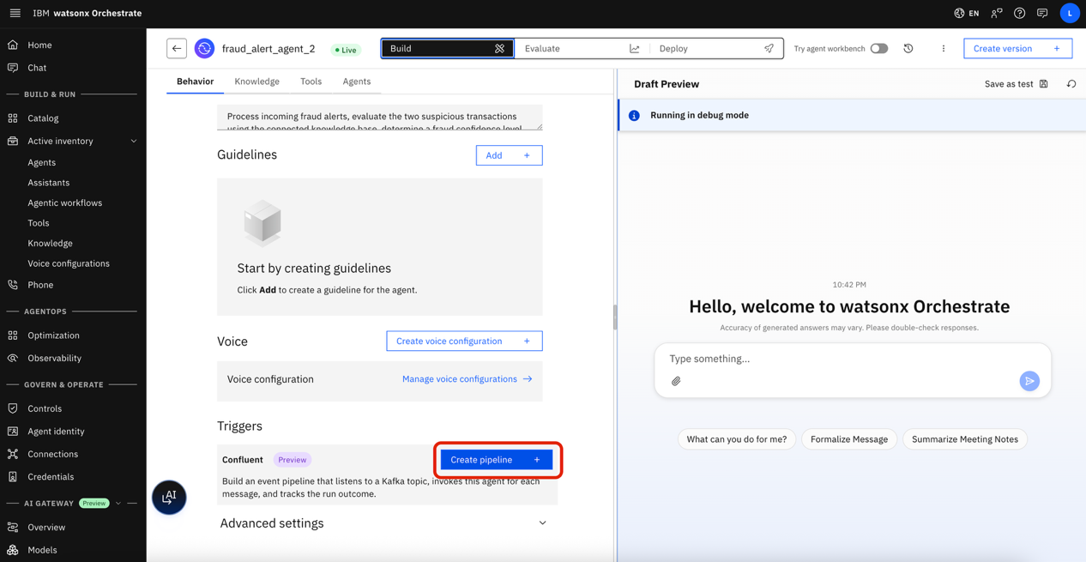

- You will see the agent specification in the user interface . Click Confluent events Pipeline.

- Name the connection: Confluent TXC
- Configure Confluent connections you saved from confluent_creds.env:
- Confluent Cloud API Key
- Confluent Cloud API Secret
- Confluent Compute Pool ID
- Confluent Organization ID
- Kafka API Key
- Kafka API Secret
- Kafka Bootstrap URL
- Schema Registry API Key (Optional - for viewing schemas)
- Schema Registry API Secret (Optional)
- Schema Registry URL (Optional)
- Flink API Key
- Flink API Secret
- Flink REST Endpoint

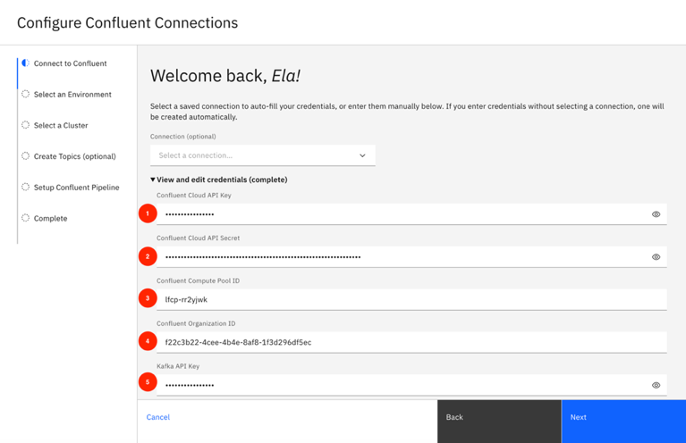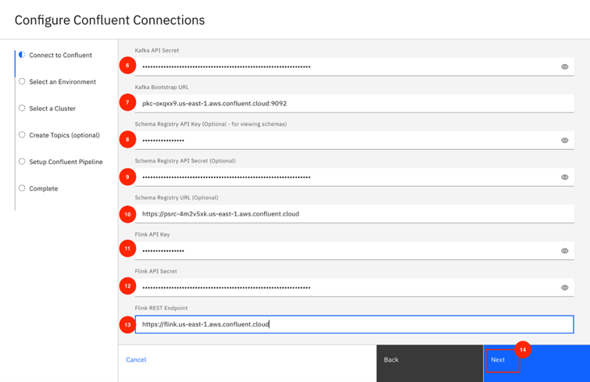

- Press Next
- Select default Environment, click Next.

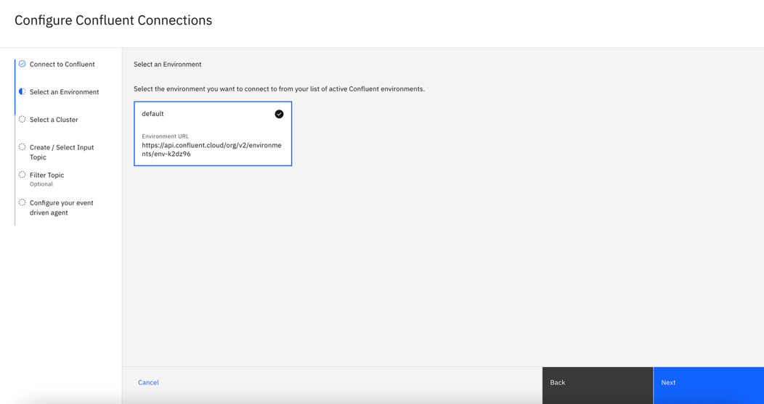

- Select the cluster you created, click Next.

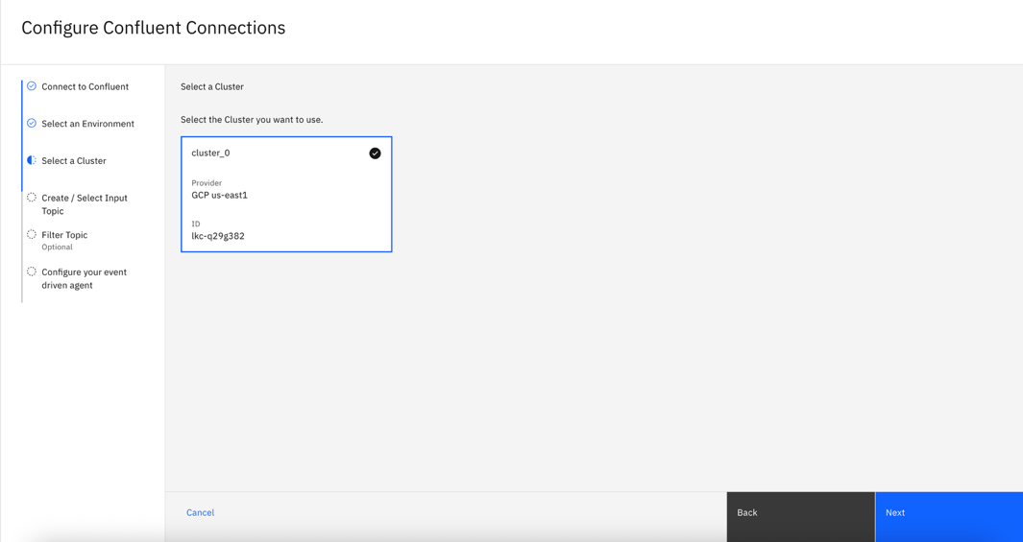

- Press Create New Topic
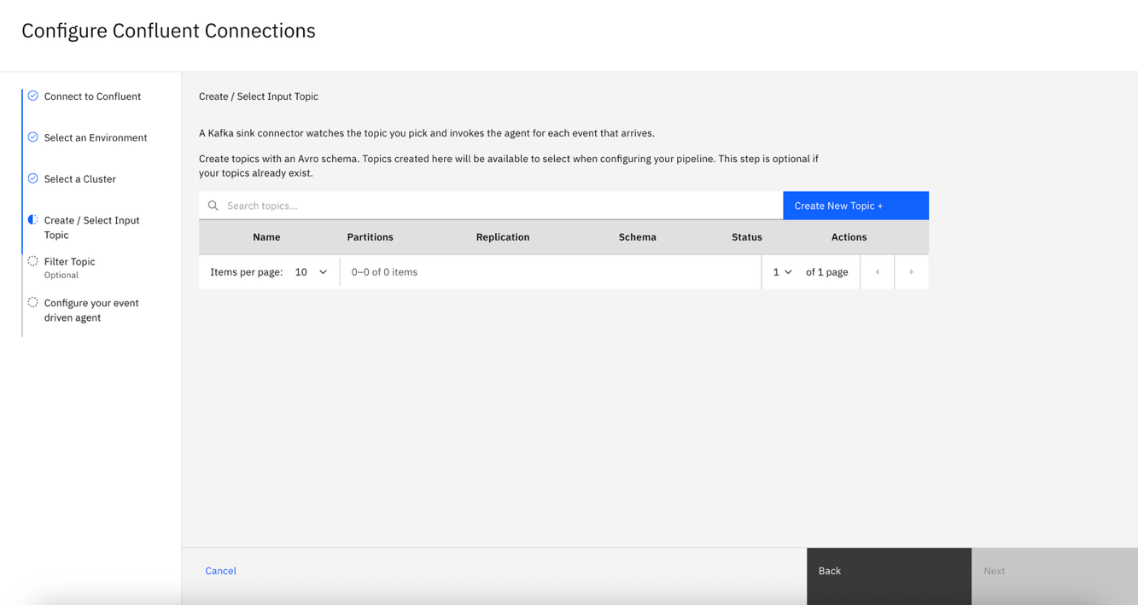

- Create the input topic
        - For the schema, select financial-fraud-detection/confluent-setup/card-present-transaction.avsc
        - Name it bank.transactions.<firstnamelastname>
        - Press Create

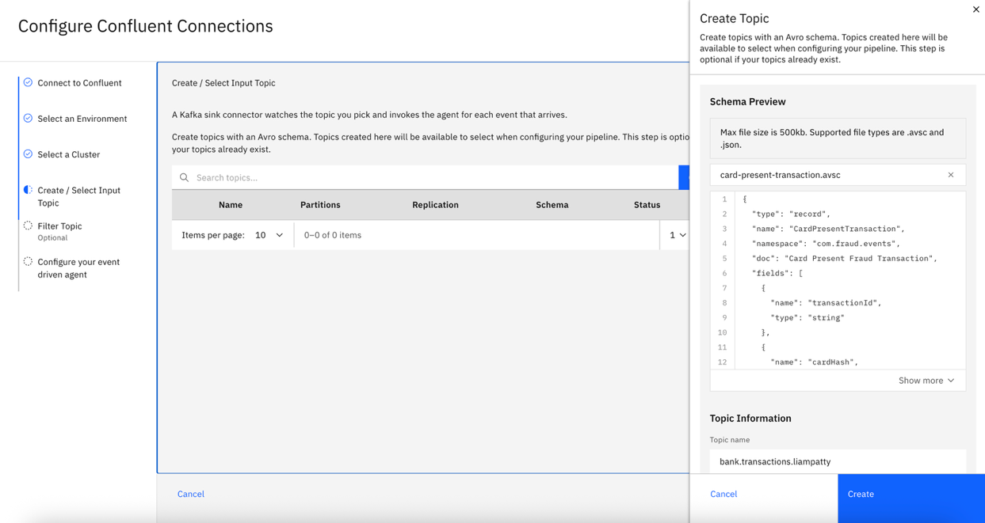

- The topic will be automatically selected, click Next
- Create the filtered topic
        - Repeat the process but select financial-fraud-detection/confluent-setup/fraud-alert-input.avsc for the schema
        - Name it bank.fraud.transactions.<firstnamelastname>
        - Press Create

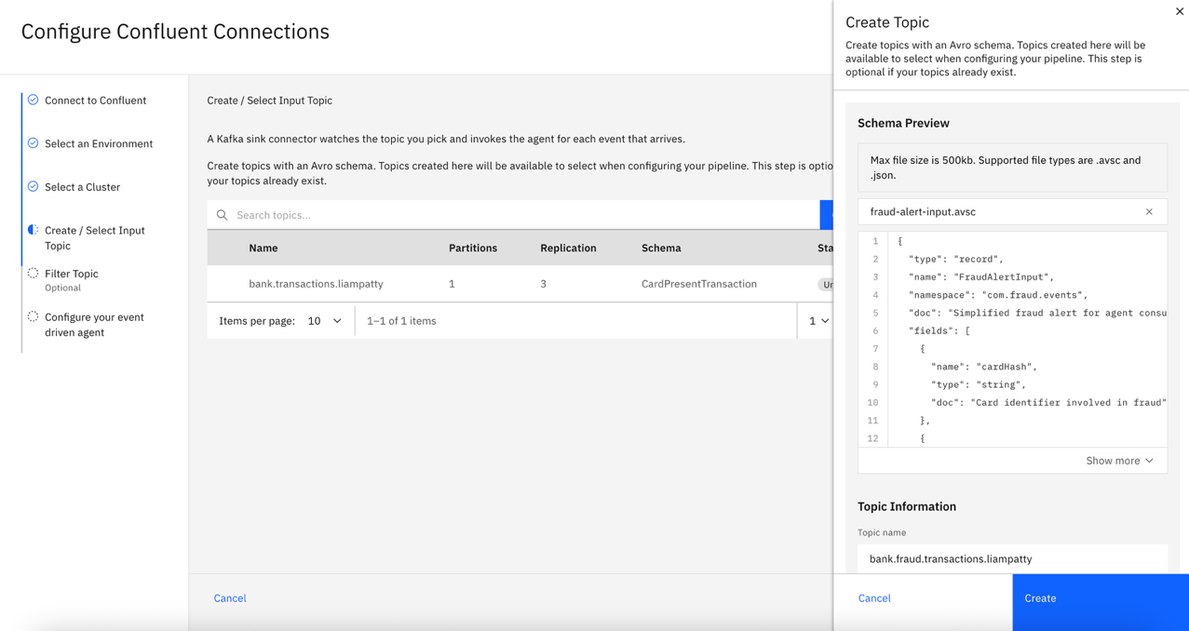

- Edit the SQL filter on the Filtered Topic
        - Press the three dots next to the selected bank.fraud.transactions topic > Edit

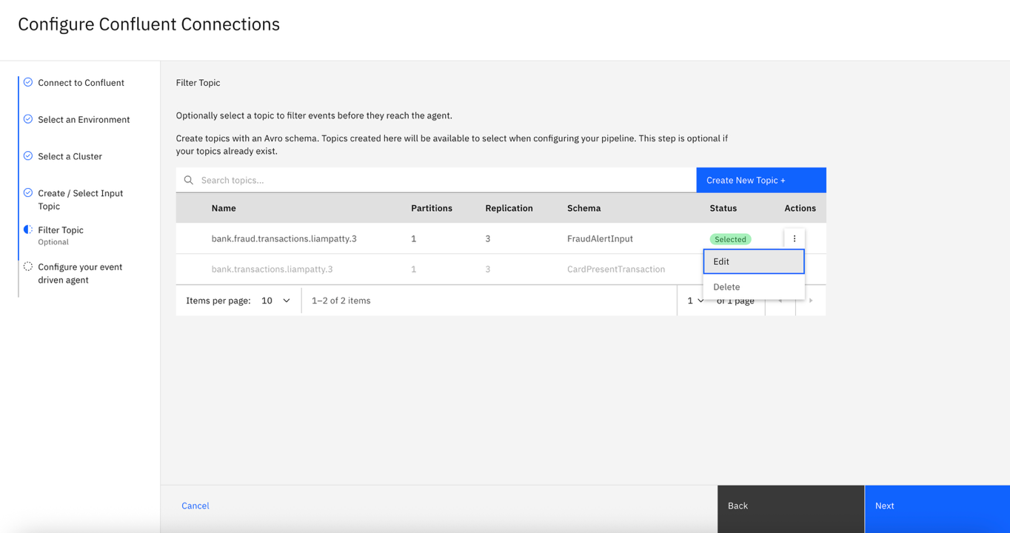

        - Select Raw SQL and copy-paste in financial-fraud-detection/confluent-setup/sql/filter.sql

          - On line 1, update the topic name to bank.fraud.transactions.<firstnamelastname>
          - On lines 23 & 32, update bank.transactions.<firstnamelastname> from the placeholder

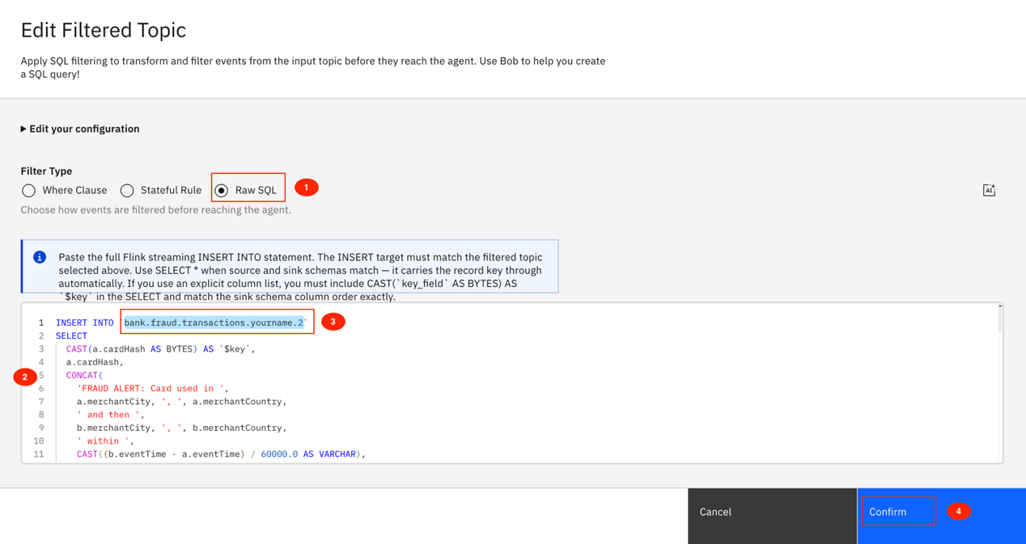

How the SQL query works:
This query performs a self-join on the bank.transactions Kafka topic to detect impossible travel fraud in
real time. It looks for pairs of approved, card-present POS transactions on the same card that occurred
within a 2-hour window, then flags any pair where the straight-line distance between the two merchant locations exceeds 300 km and the implied travel speed exceeds 800 km/h (faster than a commercial aircraft).

Matching transaction pairs are written to the bank.fraud.transactions output topic. Each alert includes a
human-readable message describing the event, the two merchant locations, the distance in kilometres, the elapsed time in minutes, the implied speed, the timestamp the alert was detected, and the transaction IDs of both triggering transactions. The card hash is used as the Kafka message key so all alerts for the same card are routed to the same partition.

- Press Next
- In the Configure Connections Screen, name your pipeline name to something like Bank Fraud Pipeline
- Set the Key Field to transactionId

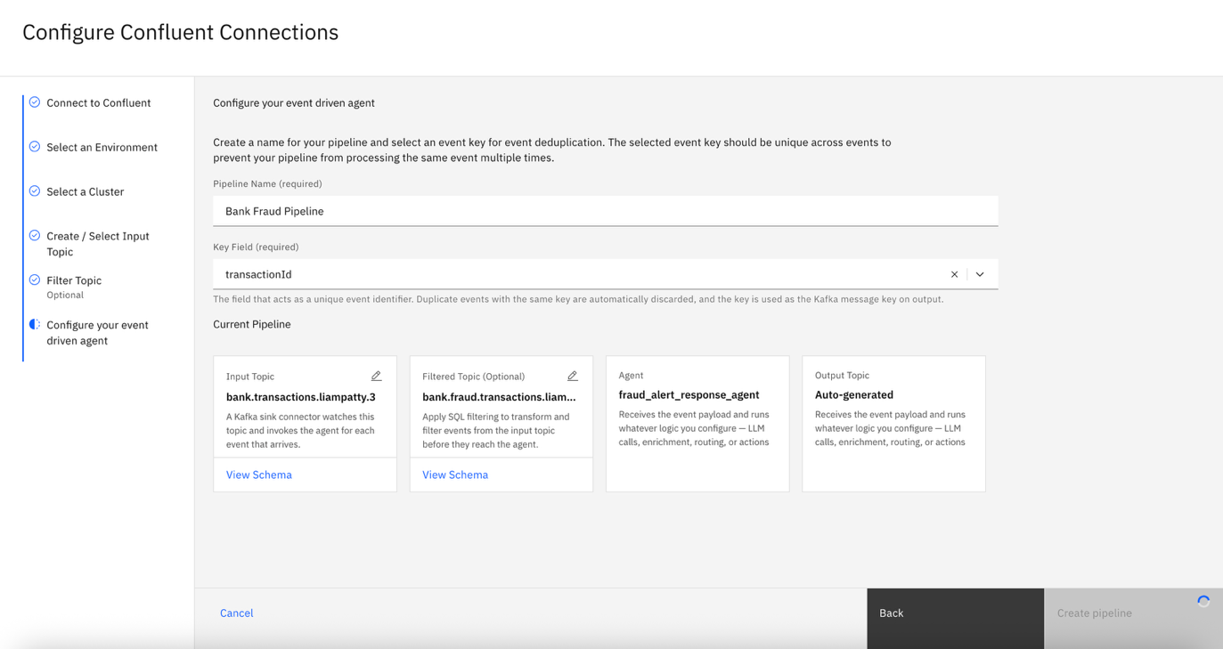

- Create the pipeline

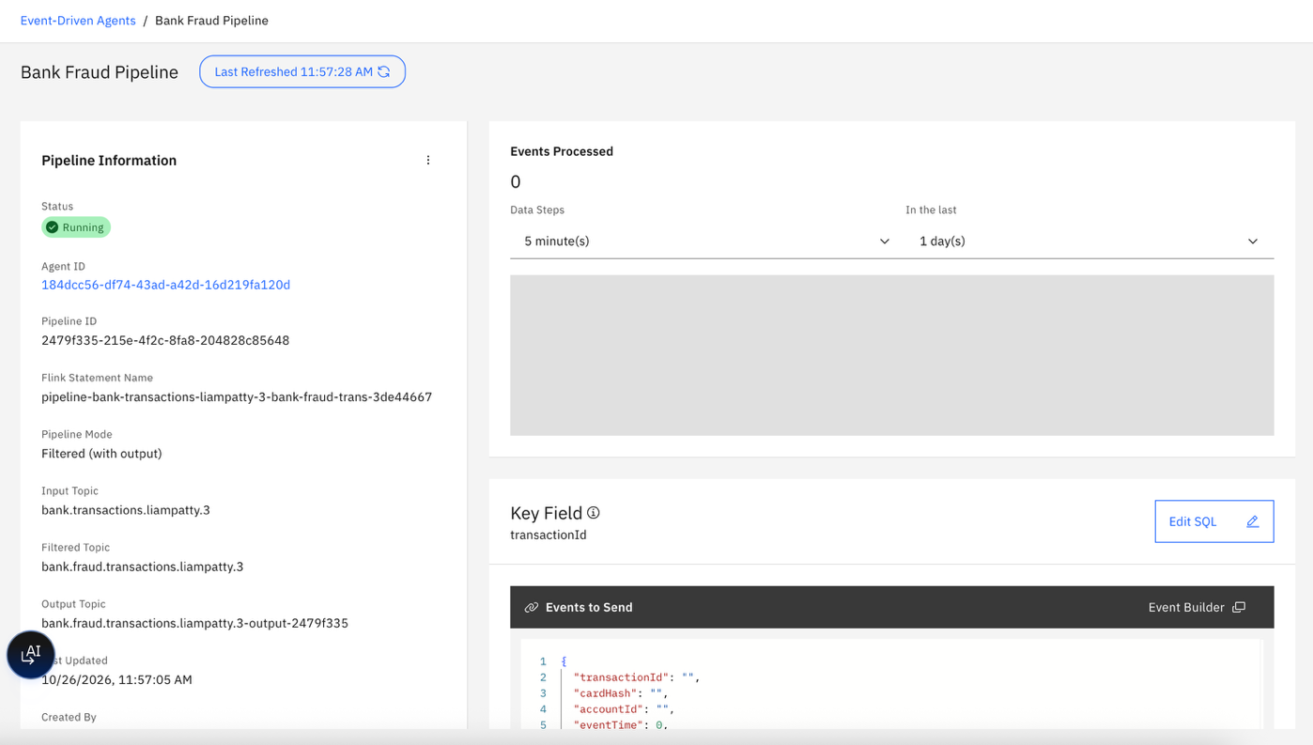

Test the fraud detection scenarios

- Scroll down on pipeline information (left pane) and click on Push Events via API

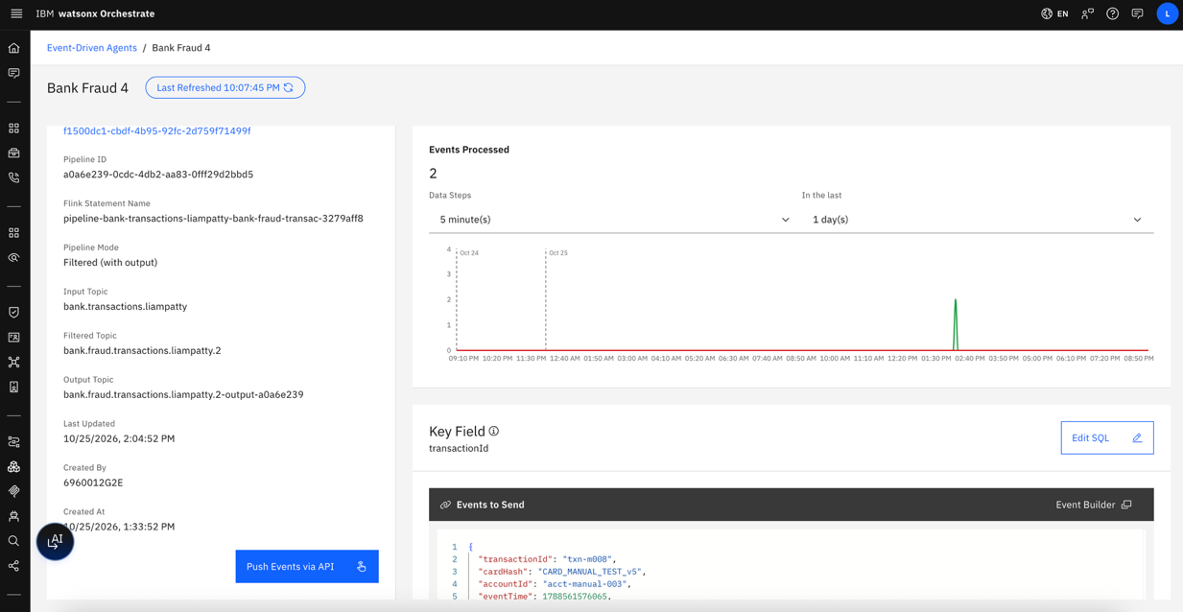

- Copy and paste the following into a prompt for Bob (one message):
  - The curl command
  - Rotate the token and copy it as well.
  - Ask Bob to send the pair-01-nyc-london events to the pipeline.

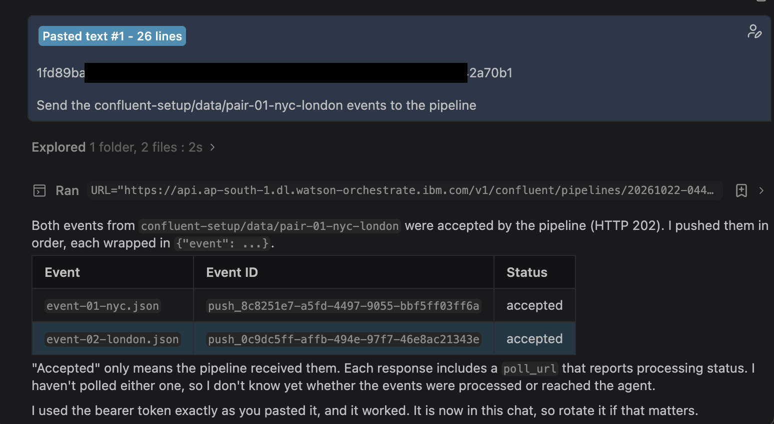

- Back in the Orchestrate Confluent pipeline UI, wait a minute, refresh the panel if needed, and see the graph update to show the new event/s have been processed

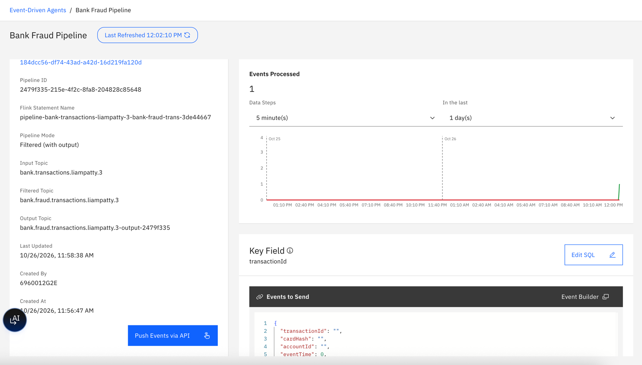

- In Confluent Cloud (https://confluent.cloud/home), navigate to your cluster topics and

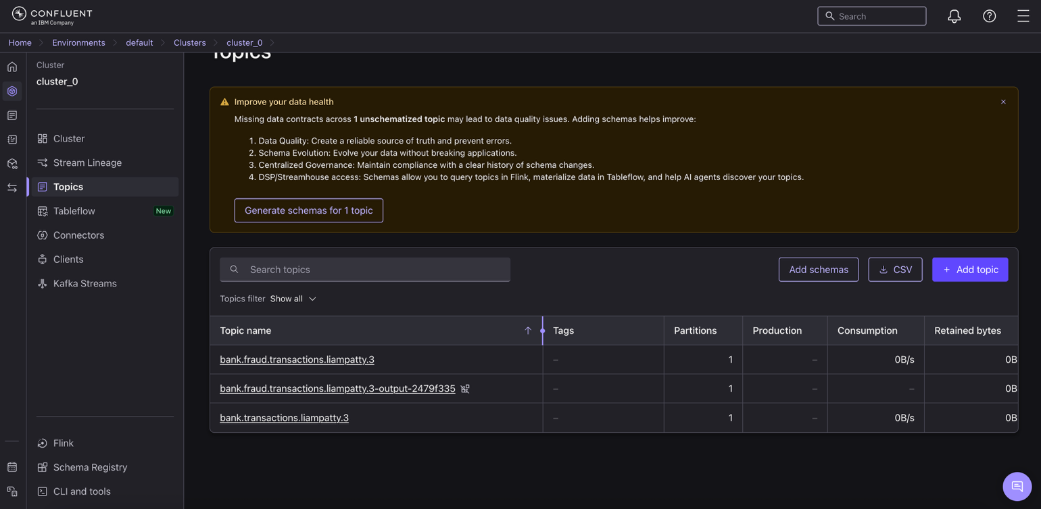

In the input topic, you should see the two events sent by Bob:

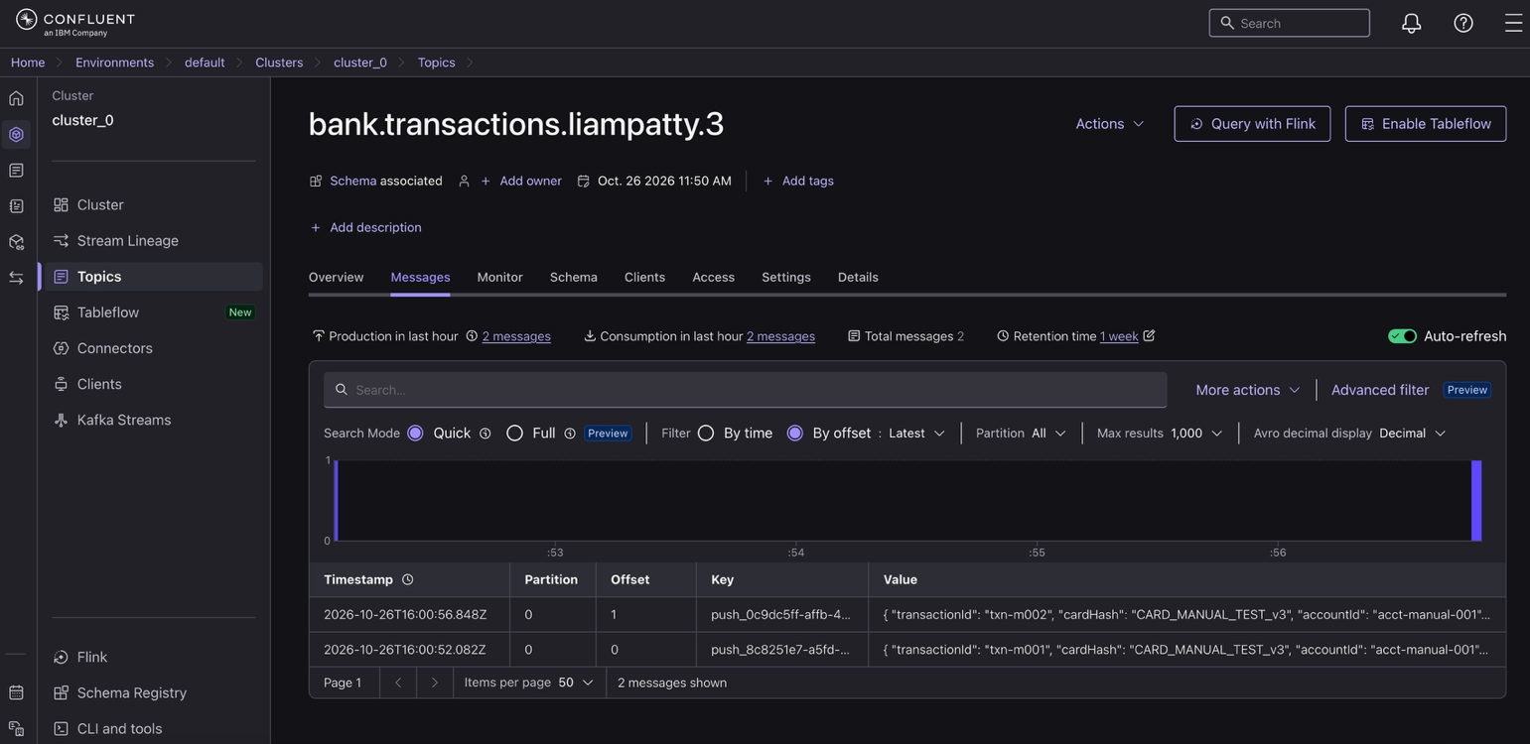

In the filtered topic, you should see the joined potential fraud event created by the filter

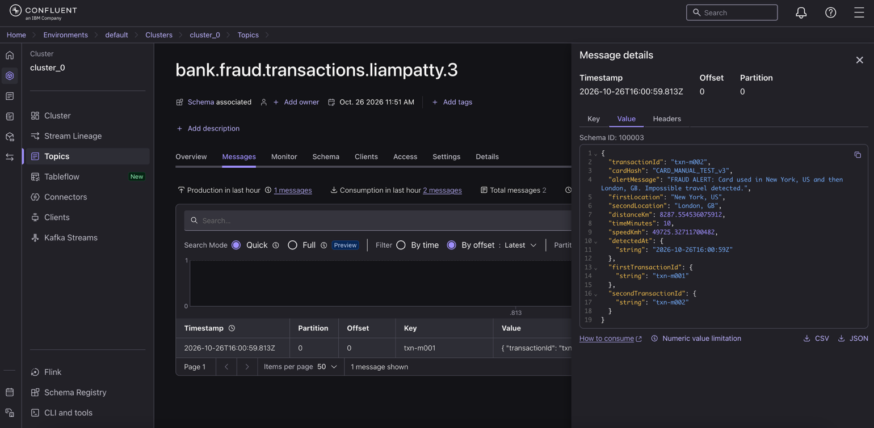

And in the auto-generated output-topic, you should see the agent response sent as a kafka event:
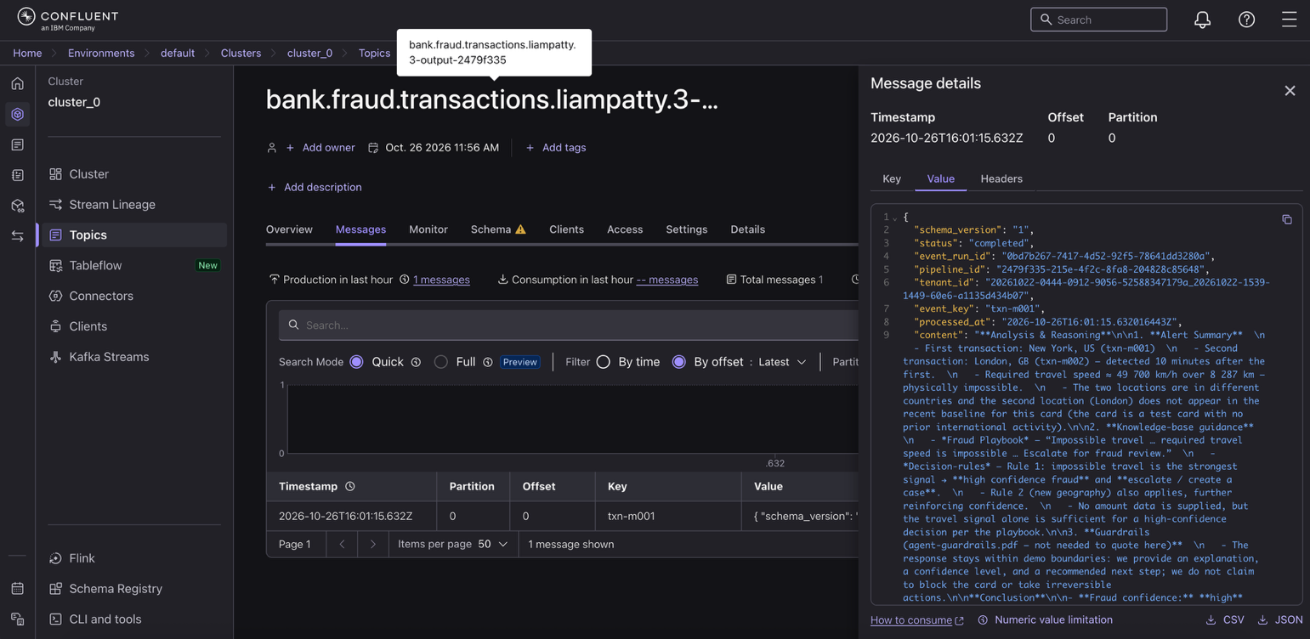

- In the Orchestrate left tab pane, go to Observability: https://ap-south-1.dl.watson-orchestrate.ibm.com/analytics?timeRange=last-1-hour

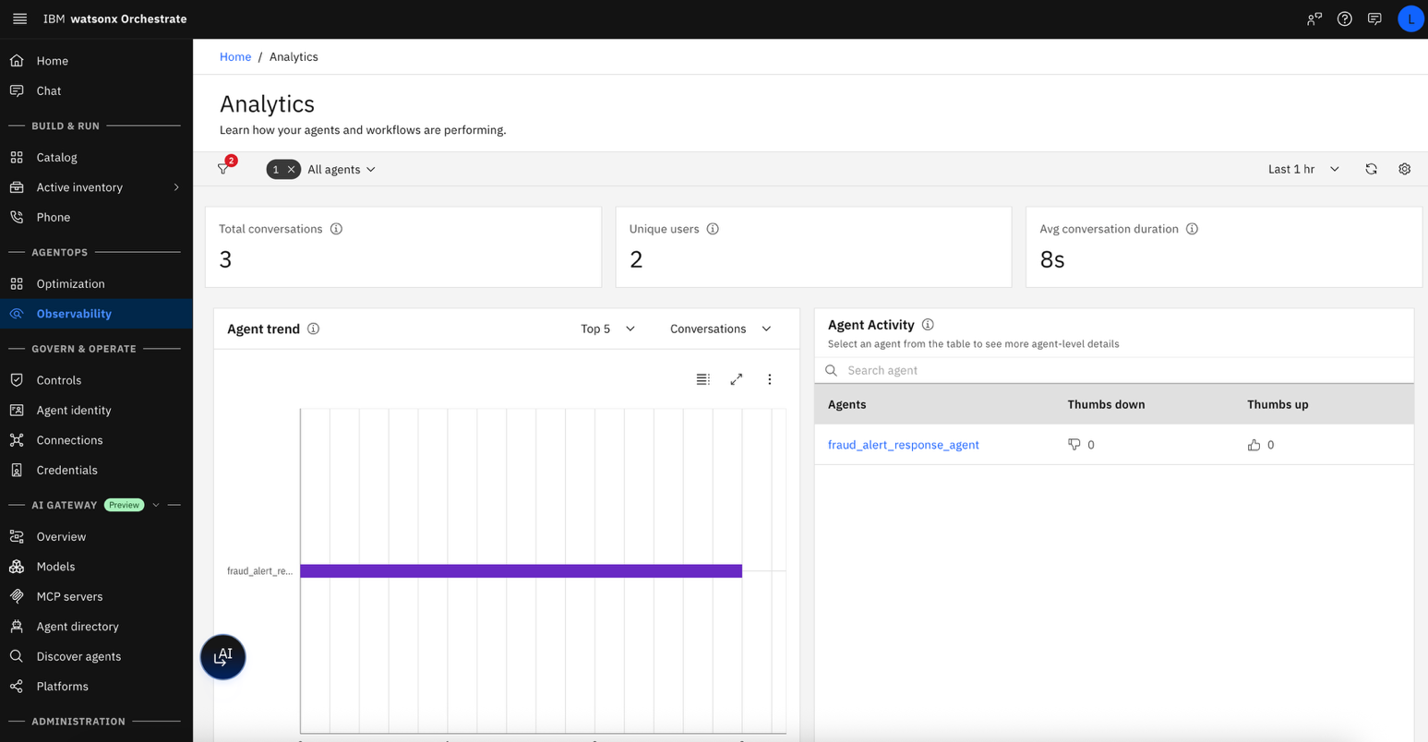

- Click on your agent, then the Conversations tab.

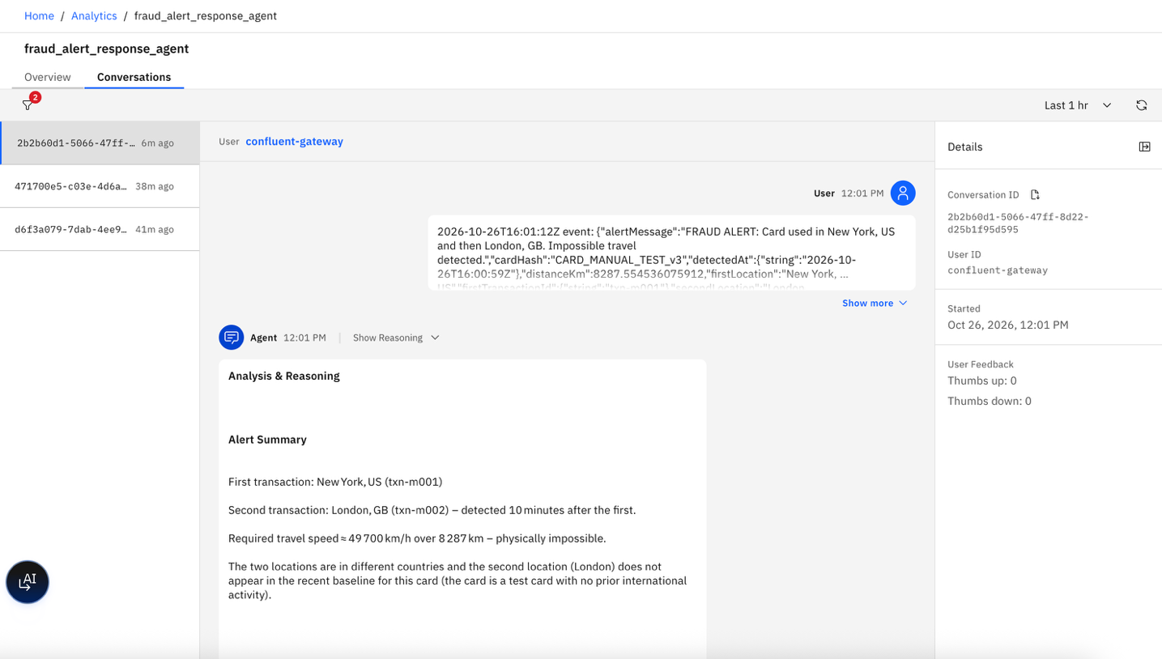

- Read the agent response

Recap

Congratulations, you just built a real-time agentic fraud detection solution combining the IBM watsonx Orchestrate agentic platform with Confluent Cloud event streaming and stream processing!
In this lab, you learned how to:
- Create and configure a watsonx Orchestrate AI agent with a fraud investigation knowledge base using IBM Bob.
- Build a real-time fraud detection pipeline in the orchestrate integration using Confluent Cloud, Kafka, and Flink SQL.
- Detect impossible-travel fraud patterns by analyzing transaction locations, distance, travel speed, and time windows.
- Integrate event-driven fraud alerts with AI-powered analysis, enabling the agent to assess risk and recommend appropriate actions.
- Validate and publish structured AI responses back to the streaming pipeline.
- Test the complete workflow—from transaction submission and real-time fraud detection through AI-powered analysis and enriched fraud responses.

Lab Reference Materials (for instructor)

Continue your learning with these references:

- Confluent Cloud Documentation: https://docs.confluent.io/cloud/current/overview.html
- Flink SQL Reference: https://docs.confluent.io/cloud/current/flink/reference/overview.html
- Schema Registry Guide: https://docs.confluent.io/platform/current/schema-registry/index.html
- watsonx Orchestrate Documentation: https://www.ibm.com/docs/en/watsonx/watson-orchestrate
- Confluent Cloud free trial: https://www.confluent.io/confluent-cloud/tryfree/

